Yogeshwar Girish Chaudhari

S3828116@student.rmit.edu.au

Master of Information Technology – IT Infrastructure and Security – MC208

Abstract

Instashare is an instant information sharing platform across all connected clients. This report presents the rationale behind such platform. It also includes the manual for installing Instashare on AWS platform.

IT Infra & Security – Assignment 2 – AWS Project

**Rationale**

With an increase in the number of personal devices for an individual, we frequently need to transfer information to and from these devices. Consider you have few long credentials for connecting to the database (e.g. hostname, username, service name such as ‘service pack google cred file access request 200’) on your desktop and wants to transfer that on your laptop. Usually, we require to email yourself the entire document that contains the credentials and download that on another machine by logging in again. You need to do this repetitive login every time you are using a public machine. It also un-necessarily consumes your disk space as we usually do not delete the file immediately after use.

We need a software that could make sharing pieces information across the devices as effortless as possible. With Instashare just drop your content into the box, and it sends it to all connected clients.

Instashare also makes group sharing easy. Just share the room credentials with the intended group and the information can be accessed by everyone subscribed to that room. If some shares information all other clients automatically receive updates

Notable features include –   
• Temporary session for quick transfer if you are on the go.   
• Simplified & Smart login process.   
• No complex setup or pairing is required.   
• Group sharing is now a link away and receivers get updates automatically.   
• No limit on file size

Advantages of building with cloud

Cloud infrastructure enables us to deliver the expected performance requirements without any long term commitments and in the most cost-efficient way possible.  
Cloud enables us to –

1. Go live in minutes without worrying about the underline hardware and software updates.
2. Provision instances as per spikes in demand to deliver expected performance.
3. The Pay-as-you-go model helps you make most out of your budget.
4. Better content delivery due to the spread of the existence of servers.
5. Little setup cost and maintenance overhead.
6. Better quality hardware.
7. Simplified launch process.

**Components**

|  |  |
| --- | --- |
| Cmd Terminal | Amazon Compute  Functionality:  Amazon EC2 is a genuine virtual computing platform that permits an individual to utilize web interfaces to dispatch cloud instances with an assorted list of pre-configured operating systems images. These images are highly suitable for deploying custom application environments right out of the box with minor adjustments. It also offers fine control over the network’s access permissions. Additionally, it introduces an effortless way of replicating current system image across many instances as per demand which minimizes system maintenance time.  Reliability:  Automate the addition and removal of computing resources for optimal performance.  Removal of a single point of failure with replacing 1 large instance with smaller ones.  Scalability:  Auto-scaling monitors the application and automatically adjusts the computing power to deliver steady performance in a cost-efficient way.  With load balancing, incoming requests can be distributed to available instances. |
| Database | Amazon RDS  Functionality:  The setting, operating, and scaling relational database instance in the cloud becomes effortless with Amazon’s Relational Database Service (RDS). It takes away all time-consuming administrative tasks such as database setup, backups, patching, and allocating hardware for scalability so that businesses can focus more on improving applications.  Reliability:  The system takes automated database snapshots.  RDS snapshot import-export is just a few clicks away in case of failure.  RDS automatically handles failovers allowing DB to perform normally.  Scalability:  Provision of multiple database instances to achieve expected performance.  Provisioning additional storage is possible. |
| Filing Box Archive | Amazon S3  Functionality:  Amazon S3 is designed to be a highly durable storage service that stores data of millions of applications worldwide. Use cases include storing and protecting website data, database backups, mobile applications data, etc. Amazon claims 99.999999999% of durability.  Reliability:  Provision for versioning  Separating storage from compute increases the reliability and reduces the risk that comes with computing failures.  Data can be replicated across different availability zones  Scalability: Each S3 can be as huge as 5TB.  100 Such buckets can be created per account  Built in scalability |

**Cost Estimate**

1. **For Small Workload – 1000/Day**

Compute Calculations  
1000/24 = 41.66 Requests per hour  
For the best possible performance and availability, 2 instances are being suggested. That means one instance can effectively handle 20 requests per hour.  
  
The costs are estimated on the fact that most of the running time will be observed on weekdays (Office Hours) with the peak time of 8:00 Hours. On weekends, the Peak time of 4 Hours has been considered.  
  
For Storage Requirements   
Consider that half of the requests are for file sharing. Each request is pushing 10 MB files after imposing file upload limits in the software.

|  |  |  |
| --- | --- | --- |
| S3 Storage | 500 Requests * 10 MB * 30 days | 150 GB/Month |
| Backup of Storage |  | 150 GB |
| Database Backup |  | 50 GB |
| Buffer |  | 150 GB |
| Total |  | **500 GB/Month** |

Based on these calculations, the estimate of the running 1000 requests per day is as follows,

|  |  |  |
| --- | --- | --- |
| **MariaDB Instance Specifications** |  | Values |
| Region |  | US Virginia |
|  |  |  |
| Instance Type |  | db.t3.micro |
| Memory |  | 1GiB |
| vCPUs |  | 2 |
| Quantity |  | 2 |
| Effective hourly cost |  | 0.012 USD |
|  |  |  |
| Pricing Strategy |  | Standard Reserved Instances |
| Reservation Term |  | 1 Year |
| Estimated Price |  | $17.52 |
| Payment Option |  | No Upfront |
|  |  |  |
| Storage amount |  | 30 GB/Month |
| Cost |  | $6.9 |
|  |  |  |
| Backup Cost |  |  |
| Storage Required |  | 100 GB |
| Database Cost (Monthly) |  | **$33.92** |
|  |  |  |
| **Amazon EC2 Instance** |  |  |
| Region |  | US Virginia |
| Estimate Type |  | EC Compute Saving |
|  |  |  |
| Instance Specifications |  |  |
| Operating System |  | Linux |
| **Variable Workload** |  | --- |
|  | | |
| **Spike Pattern 1** |  | For weekdays – Monday to Friday |
| Baseline Instances |  | 2 |
| **Peak Instances** |  | 3 |
| Duration of Peak |  | 8:30 Hr |
|  |  |  |
| **Spike Pattern 2** |  | For weekends – Saturday & Sunday |
| Baseline Instances |  | 1 |
| Peak Instances |  | 2 |
| Duration of Peak |  | 04:00:00 Hr |
|  |  |  |
| **Reservation Options** |  |  |
|  |  |  |
| Reservation Terms |  | 1 Year |
| Payment Terms |  | NO UPFRONT |
|  |  |  |
|  |  |  |
| **Amazon Elastic Block Storage** |  |  |
| SSD Type |  | General Purpose SSD |
| Storage Amount |  | 30 GB |
| Snapshot Frequency |  | 2x Daily |
| **Data Transfer** |  |  |
|  |  |  |
| (Inbound Data Transfer) All Other Regions |  | 100 GB/Month |
| (Outbound Data Transfer) All Other Regions |  | 100 GB/Month |
|  |  |  |
| **Compute Monthly Cost** |  | **$37.89** |
|  |  |  |
| **Simple Storage Service S3** |  | S3 Standards |
|  |  |  |
| Data Transfer |  | 500 GB/Month |
|  |  |  |
| Storage |  | 500 GB/Month |
| PUT, COPY, POST, LIST requests to S3 |  | 50000 |
| GET, SELECT, and all other requests from S3 | | 50000 |
| Data Scanned by S3 |  | 500 GB/Month |
| Data returned by S3 Select |  | 500 GB/Month |
| Total Monthly Cost |  | $13.12 |
|  |  |  |
| Data Transfer |  |  |
| Inbound Data Transfer |  | 500 GB/Month |
| Outbound Data Transfer |  | 1000 GB/Month |
| Data Transfer Estimates |  | $20.00 |
|  |  |  |
| Monthly Estimated Cost for S3 |  | **$33.12** |
|  |  |  |
| Elastic IP |  |  |
| Number of EC2 instances |  | 4 |
| Number of EIPs per instance |  | 1 |
| Number of hours each EIP is attached to an EC2 instance | | 720 |
| Number of hours each EIP is associated with a stopped instance or is unattached | | 310 |
| Total Monthly Cost |  | $6.40 |
|  |  |  |
| **Support Estimate** |  |  |
| Enhanced technical support |  | $22 |
| response times |  | Less than 12 Hours |
|  |  |  |
|  |  |  |
| **Total monthly cost  (Database + Compute + Storage + Developer Support)** |  | **$133.33 * All prices are in USD** |

1. **For 1000000/Requests per Day Systems**

1000000/24 = 41666 requests per hour  
From our earlier estimate, each t2.micro (1 GB memory and 2 vCPUs) can handle 20 Requests per hour.   
Therefore, t3a.xLarge with 16 GB memory and 4 vCPUs can handle 64 times more requests.

|  |  |  |
| --- | --- | --- |
| Number of Single t2 Instances required | (1000000/24)/20 | 2083 |
| Number of t3 Large Instances | (1000000/24)/20/64 | ~32 |

For the best possible performance, we are quoting 32 instances.

*Error logs will be stored at the EC2 application folder. That will be moved to another S3 instance every 2 Hours. 100 GB per instance has been allotted for this purpose.  
*The costs are estimated on the fact that most of the running time will be observed on weekdays with the peak time of 8:00 Hours. On weekends, the Peak time of 4 Hours has been considered.  
  
**For Storage Requirements**   
Consider that half of the requests are for file sharing. Each request is pushing 1 MB file after imposing strict file upload limits in the software.

|  |  |  |
| --- | --- | --- |
| Storage | (1000000/2) Requests * 1 MB * 30 days | 15000 GB/Month |
| Storage Backup |  | 15000 GB |
| Database Backup |  | 500 GB |
| Total |  | 30500 GB/Month |

**AWS Priority Support**  
Business support package providing on-demand support in less than 15 mins have been added in case of an unexpected event.   
   
Based on these calculations, this is the estimate of the running 1000000 requests per day

|  |  |
| --- | --- |
| **MariaDB Instance Specifications** | |
| Region | US Virginia |
| Instance Type | db.m5.xlarge |
| Memory | 16 |
| vCPUs | 4 |
| Quantity | 20 |
| Effective hourly cost | $0.2191 |
| Pricing Strategy | Standard Reserved Instances |
| Reservation Term | 1 Year |
| Backup Cost |  |
| Storage Required | 600 GB |
| Cost (Monthly) | $57 |
|  |  |
| Storage amount – Per Instance – Total (15*32 = 480 GB) | 15 GB/Month |
| Cost |  |
| **Database Estimated Price** | **$3290.36** |
|  |  |
| **Amazon EC2 Instance** |  |
| Region | US Virginia |
| Estimate Type | Advance Estimate |
|  |  |
| **Instance Specifications** |  |
| Operating System | Linux |
| Storage | 100 GB |
| Workload |  |
|  |  |
| Spike Pattern 1 |  |
| Baseline Instances | 15 |
| Peak | 32 |
| Duration of Peak | 8:00 Hr |
|  |  |
| Spike Pattern 2 |  |
| Baseline Instances | 7 |
| Peak | 10 |
| Duration of Peak | 04:00 |
|  |  |
| Reservation Options |  |
| Reservation Terms | 1 Year |
| Payment Terms | No Upfront |
|  |  |
| Amazon Elastic Block Storage | |
| SSD Type | General Purpose |
| Storage Amount | 100 GB/ |
|  |  |
| Snapshot Frequency | 2x Daily |
|  |  |
| Data Transfer |  |
| Inbound Data Transfer |  |
| All Other Regions | 15000 GB/Month |
|  |  |
| Outbound Data Transfer |  |
| All Other Regions | 16500 GB/Month |
|  |  |
| EC2 Data Transfer Monthly Cost | $104.00 |
|  |  |
| **EC2 Monthly Total** | **$2168.21** |
|  |  |
| **Simple Storage Service S3** |  |
|  |  |
| Specifications | S3 Standards |
|  |  |
| Data Transfer |  |
|  |  |
| Storage | 30500 GB/Month |
| PUT, COPY, POST, LIST requests to S3 | 30000000 |
| GET, SELECT, and all other requests from S3 | 30000000 |
| Data Scanned by S3 | 15000 GB/Month |
| Data returned by S3 Select | 15000 GB/Month |
| Total Monthly Cost | $ 239.10 |
|  |  |
| Data Transfer |  |
| Inbound Data Transfer | 15000 GB/Month |
| Outbound Data Transfer | 30000 GB/Month |
|  |  |
| **Storage Estimated Total** | $**1504** |
|  |  |
| Elastic IP |  |
| Number of EC2 instances | 32 |
| Number of EIPs per instance | 1 |
| Number of hours each EIP is attached to an EC2 instance | 730 |
| Number of hours each EIP is associated with a stopped instance or is unattached | 310 |
| Total Monthly Cost | **$49.6** |
|  |  |
| **Support Estimate** |  |
| Enhanced technical support – Business Support | $1000-1200 |
| response times | Less than 15 Minutes |
|  |  |
| **Total monthly cost (*All Figures are in USD)** | **$7012.17 + $1000 for Support** |

1. **For 1000000+ Requests per Day**

Due to unknown upper threshold, estimating the cost for such system is difficult task.  
  
Estimate for 1,000,000 Requests/day can be considered as a template for quoting for such a system.  
  
An increase in every 1000000 Requests per day will result in an estimated running cost to increase by $7012.17 per month because this would essentially require provisioning additional resources for catering increasing requests.  
  
It also means that, for catering every additional 1000 requests/day, estimated monthly cost would increase by 7 dollars.

**Installation Manual**

|  |  |  |
| --- | --- | --- |
| Sr. | Task Description | Est. Time |
| 1 | AWS EC2 Configuration  Creating EC2 instance  Assigning Static IP address to Instance  Connecting to EC2 instance  Prepare Application Environment   1. Install Apache2 Package (Web Server) 2. Install PHP Modules 3. Install mysqli driver 4. Install cURL for PHP for Pusher plugin (Dependency) 5. Change permissions   Uploading Application Folder to Web Server | 20 Mins |
| 2 | S3 Bucket Setup  Creating a Storage Bucket in S3 Instance | 5 Mins |
| 3 | Setting Up RDS (Relational Database System – MariaDB)  Creating RDS instance  Assigning permissions to RDS | 20 Mins |
| 4 | Changing config variables of applications  Configuring Database Variables  Configuring Base URL of application | 5 Mins |
| 5 | Exporting Snapshot to S3  Backing up database  Creating Key for Exporting RDS  Creating Service Role for RDS export  Taking Snapshot of the database | 20 Mins |
| 5 | Testing Application | 10 Mins |
|  |  | 80 Mins |

**AWS EC2 Configuration**

**1.1 Creating EC2 instance**

1. Login to your AWS account  
   Select EC2 from Services -> Compute -> EC2
2. Click On Launch Instance

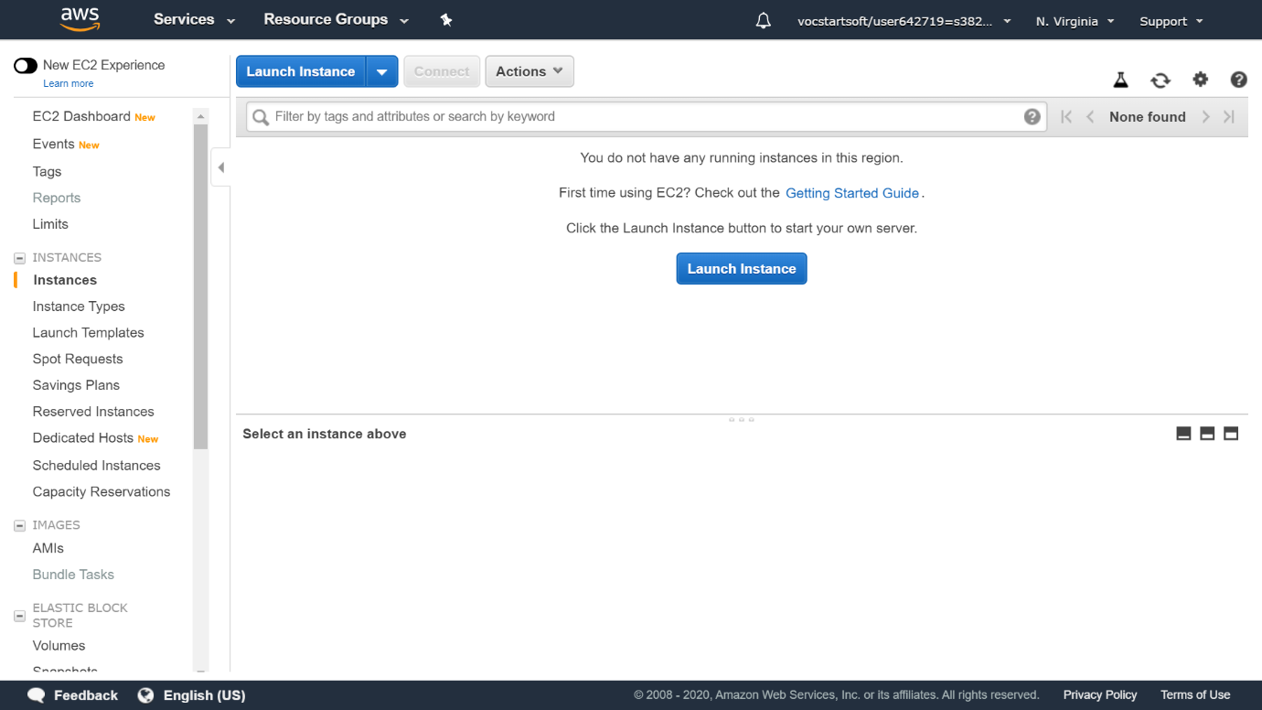

1. Configuring Server as Per Requirements which includes following things
2. Choose Operating System Distribution
3. Choose Instance Type
4. Configure Instance
5. Add Storage
6. Add Tags (Skipped)
7. Configure Security Groups
8. Review
9. Launch
10. Choose Ubuntu Server with 64-bit architecture  
      
    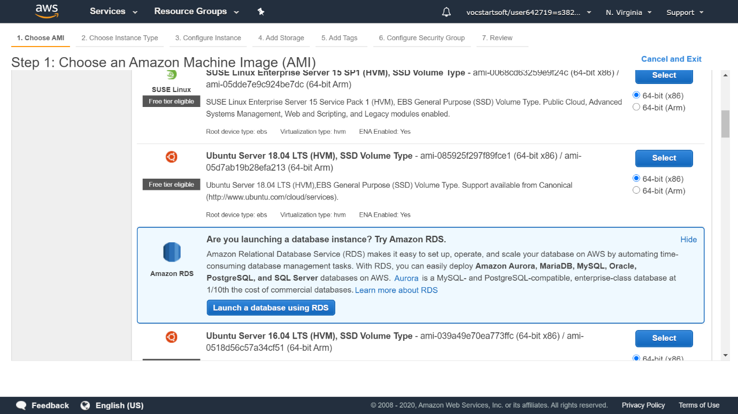
11. Chose instance type  
      
    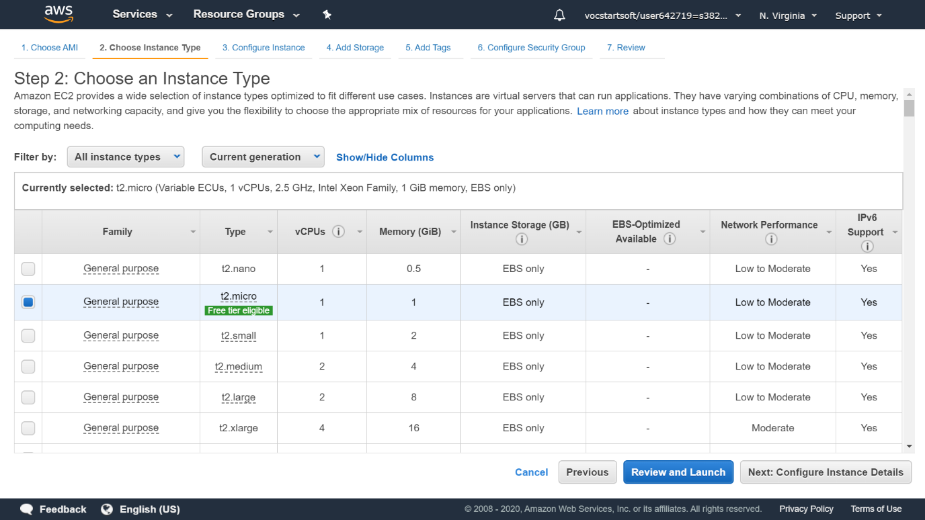
12. Assign 1 instance only. Leave everything else unchanged for now.  
      
    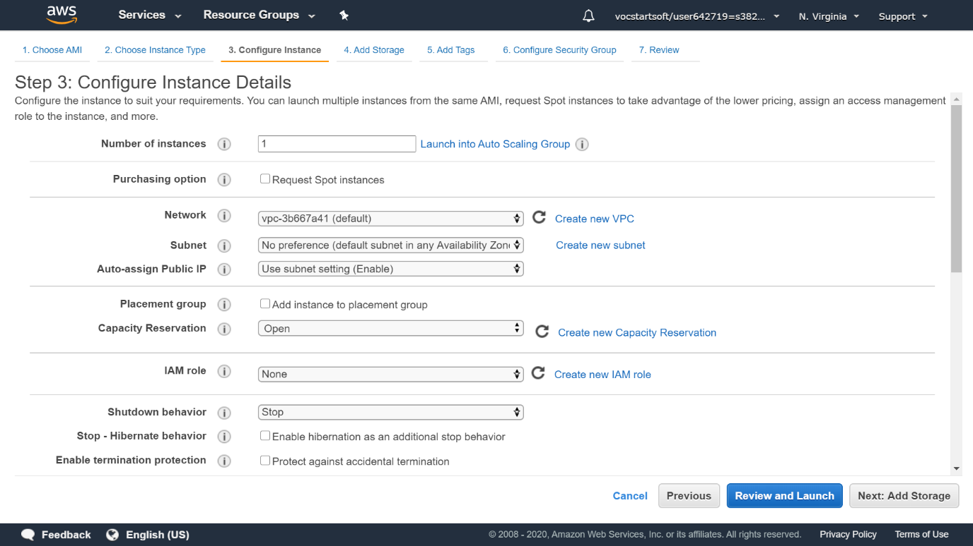
13. Provision Storage   
    **Single Volume - Root  
    Size Allocation 20-30 GB  
    Volume Type General Purpose SSD**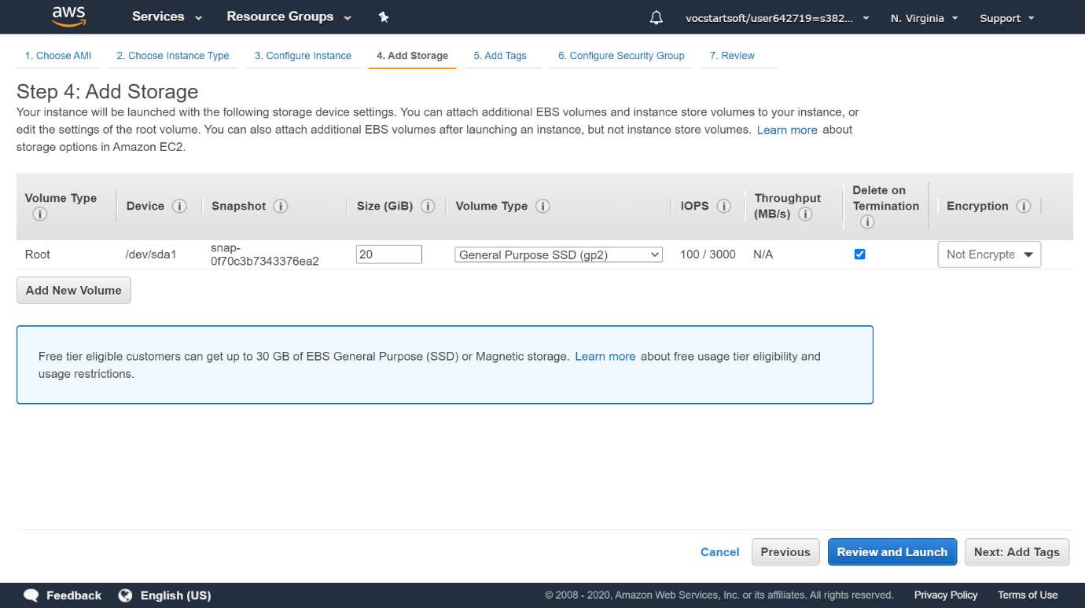
14. Skip Adding Tags
15. Create a Security Group

**Provide Group** Name : PHP WebServer Security Group  
Provide understandable description for this security group for future reference.  
Rule 1 : SSH will be present by default  
Rule 2 : Add HTTP and change source to Anywhere  
Rule 3 : Add HTTPS and change source to Anywhere  
  
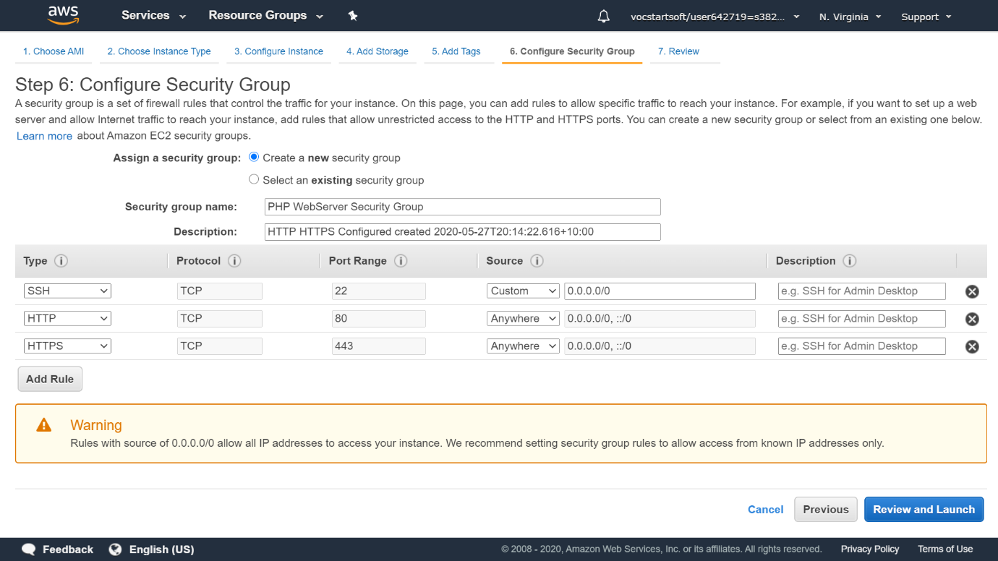

1. Verify and Click Review and Launch  
   Review the instance configuration carefully and click launch
2. You will be asked to create Key-Pair   
     
   **\*If you are using an existing account you can use existing key-pair for accessing your EC2 instance. Skip the creating a new key-pair section.**

**For creating new key-pair**Select Create new key-pair and provide a descriptive key-pair name. Download the key-pair.   
**\*Backup this newly downloaded key pair since there is no way to retrieve this in the future. if you lose it or impose incorrect permissions that are restricting you from changing the permissions then migrating that system to new EC2 instance is a tedious task.**

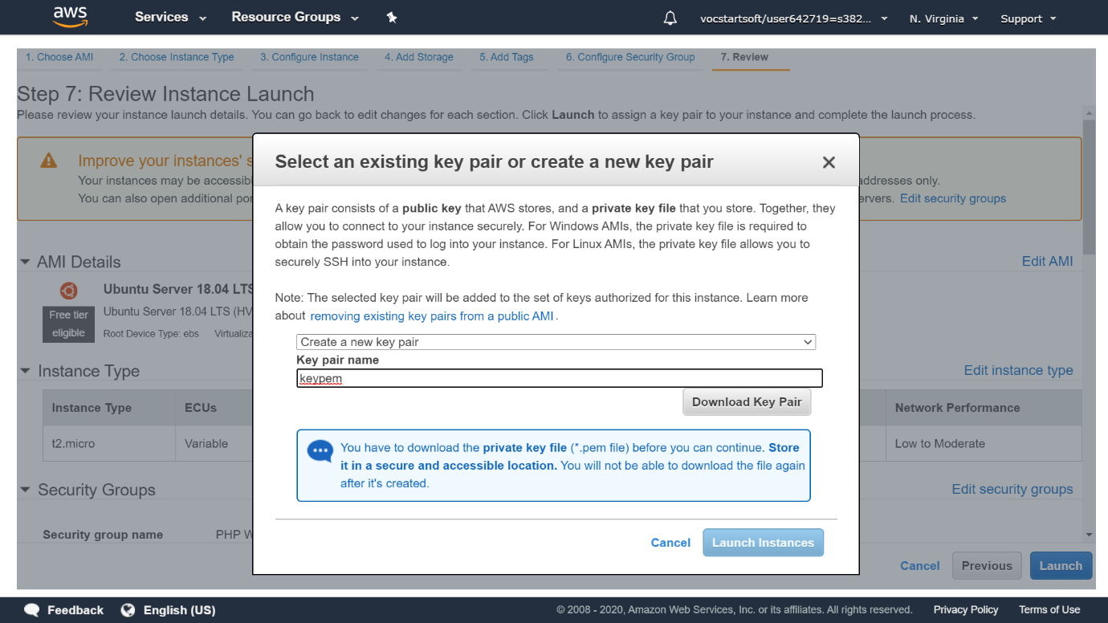

If you have followed all the steps correctly so far, you should see this window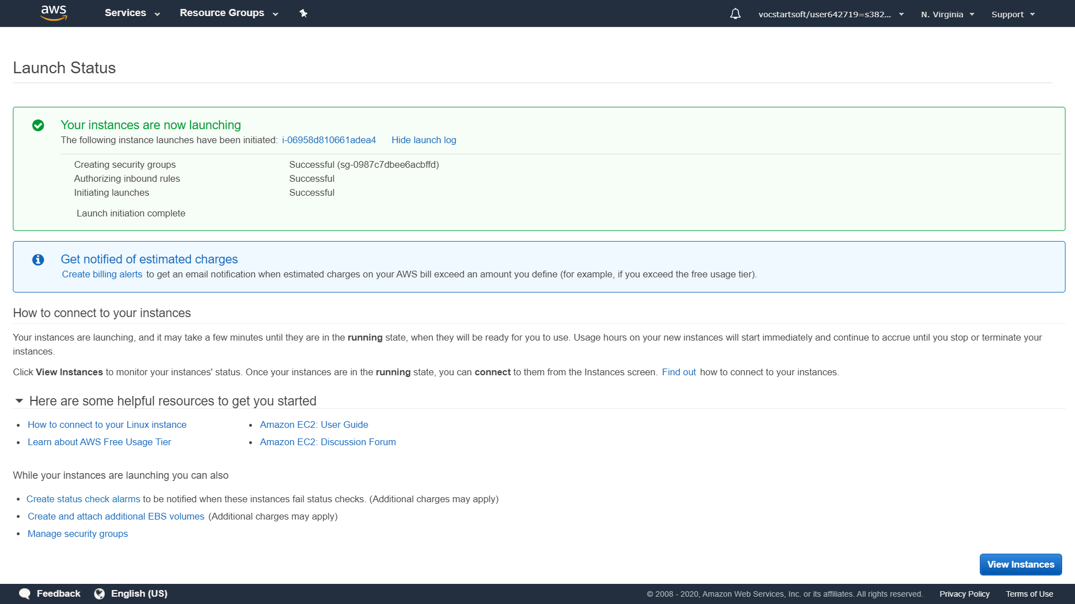

Go to instances and you will see an entry of newly created instance.  
  
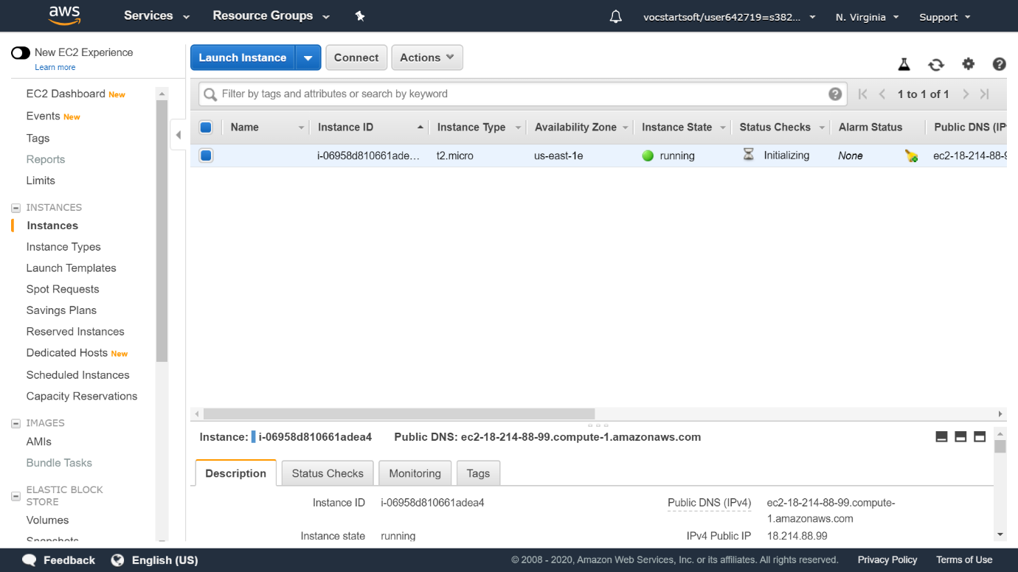

**Congratulations**. Your EC2 instance is now up and running.  
  
**1.2 Assigning Elastic IP to EC2 instance.**

1. Assigning Static IP Address to EC2 instance  
   Network & Security -> Elastic Ips -> Allocate Elastic IP address  
   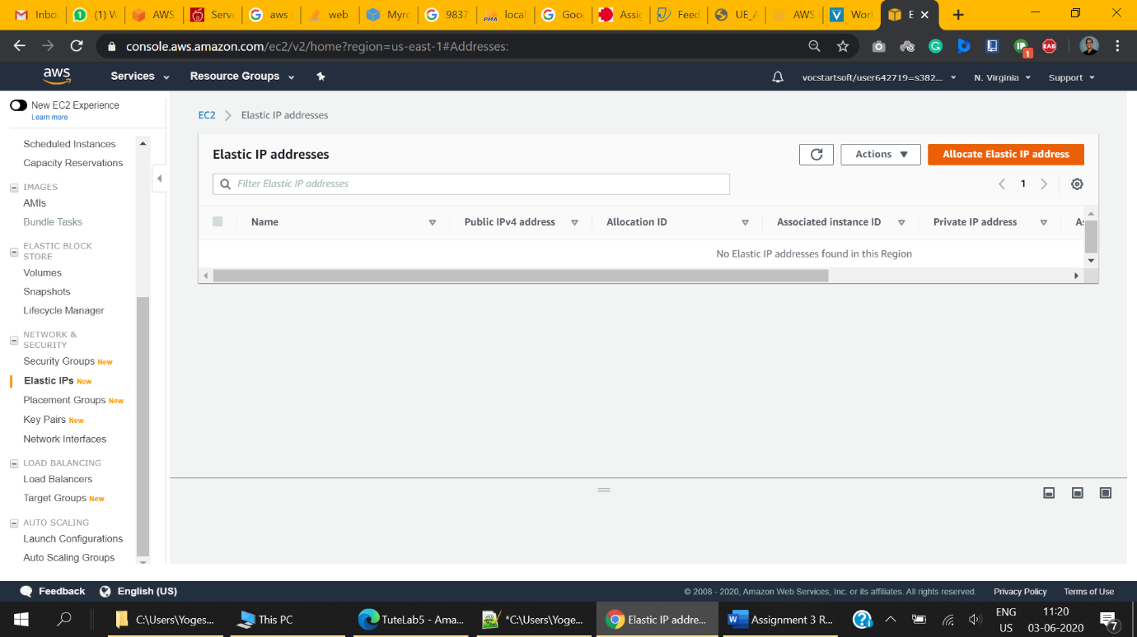
2. Select Amazon’s pool of IPv4 addresses

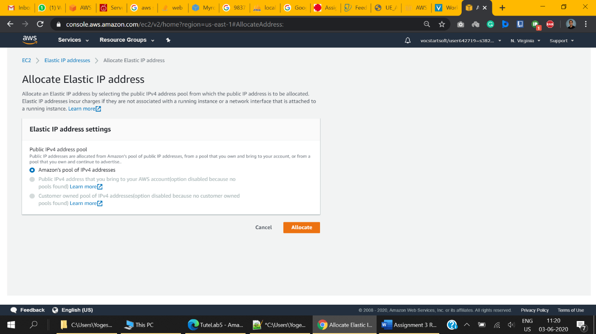

1. After successful allocation, you will see the elastic IP address allocated to your account.  
     
   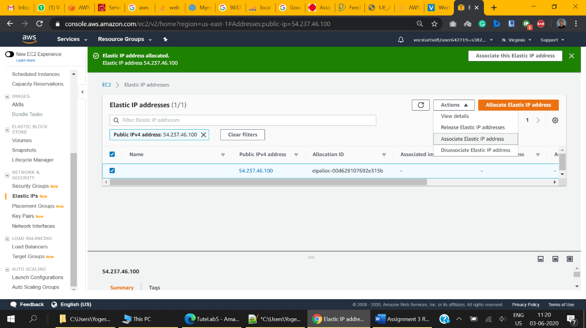
2. Click on Associate this Elastic IP address to associate this newly create IP address to one of your EC2 instance.  
   Alternatively,

* Select the Elastic IP you want to associate from list of allocated IPs
* Click on Actions -> Associate Elastic IP address

1. Association of IP with Instance
   1. Select Resource type as Instance
   2. Select the EC2 instance from instance drop-down. (The one we created for hosting our application.)
   3. Leave everything else to default and associate.  
        
      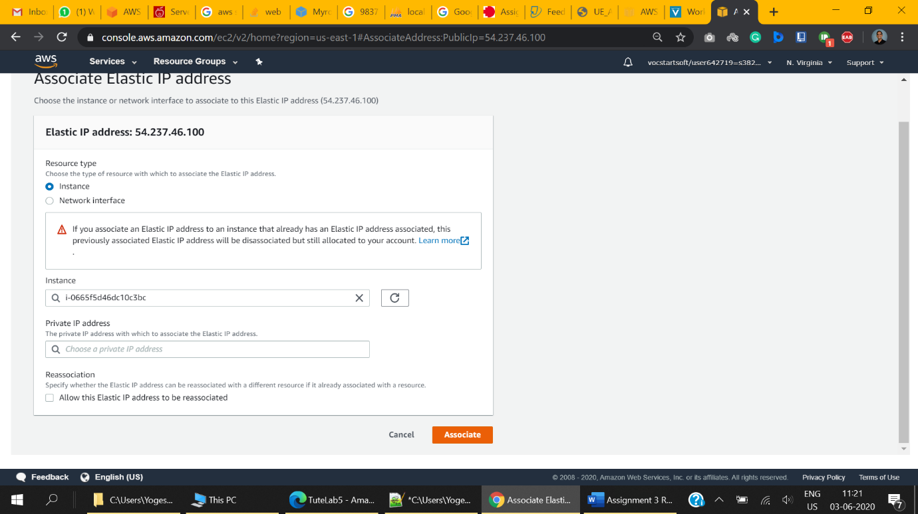
2. 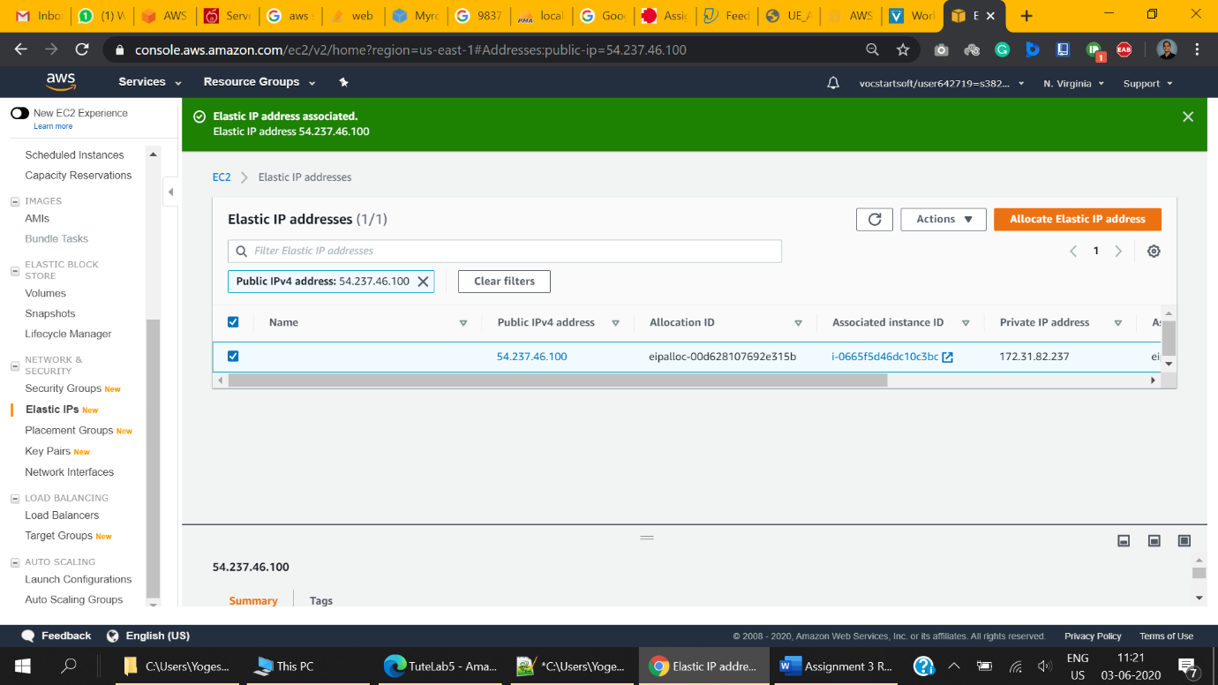

**1.3 Connecting to EC2 instance**We will be connecting to EC2 using the command line for modifying systems state such as installing packages like apache, starting and stopping them, etc. We are using the ubuntu based system for establishing this connection.   
We will be using WinSCP for uploading files to the server.

1. Move to your working directory and make sure that you have downloaded key-pair in that directory
2. Change the permission of the key-pair file to 400 using the following command  
   sudo chmod 400 <key-pair-name>.pem
3. Validate the permissions using  
   sudo ls -l
4. Permissions should look like -r--------   
   (Only read access for owner and no access for others)
5. From a list of EC2 instances, select the instance you wish to connect to.  
   *If the instance is not already in running state then,   
   select instance -> actions -> instance state -> start  
     
   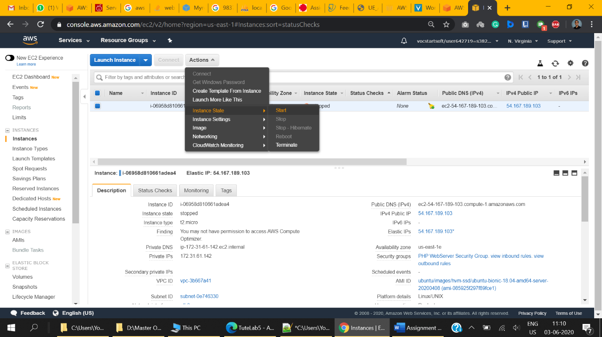
6. Click on connect button located at top. A pop-up window will appear.
7. Select **“Standalone SSH client”** as connection method
8. Copy the example command as shown below  
     
   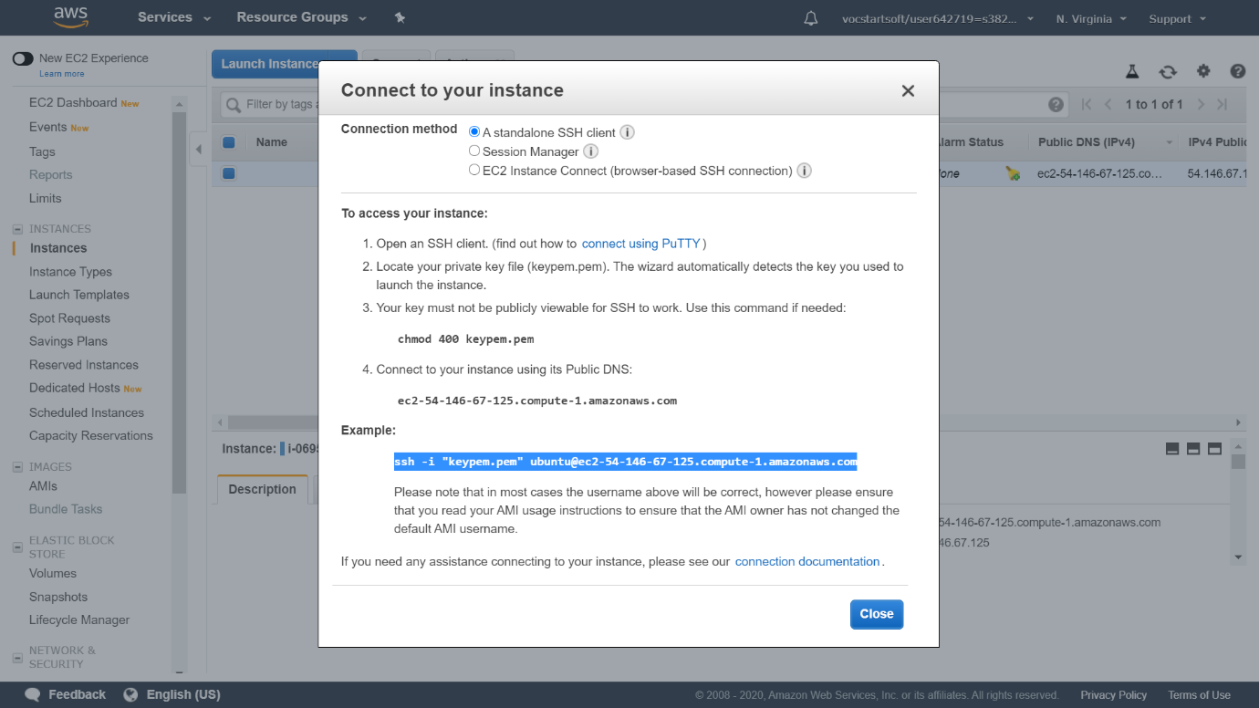
9. Go to ubuntu based terminal and execute this command. Make sure that your key-pair name matches with the example command your copied.  
     
   ssh -i "keypem.pem" [ubuntu@ec2-54-167-189-103.compute-1.amazonaws.com](mailto:ubuntu@ec2-54-167-189-103.compute-1.amazonaws.com)
10. Congratulations. You have now gained access to EC2 instance

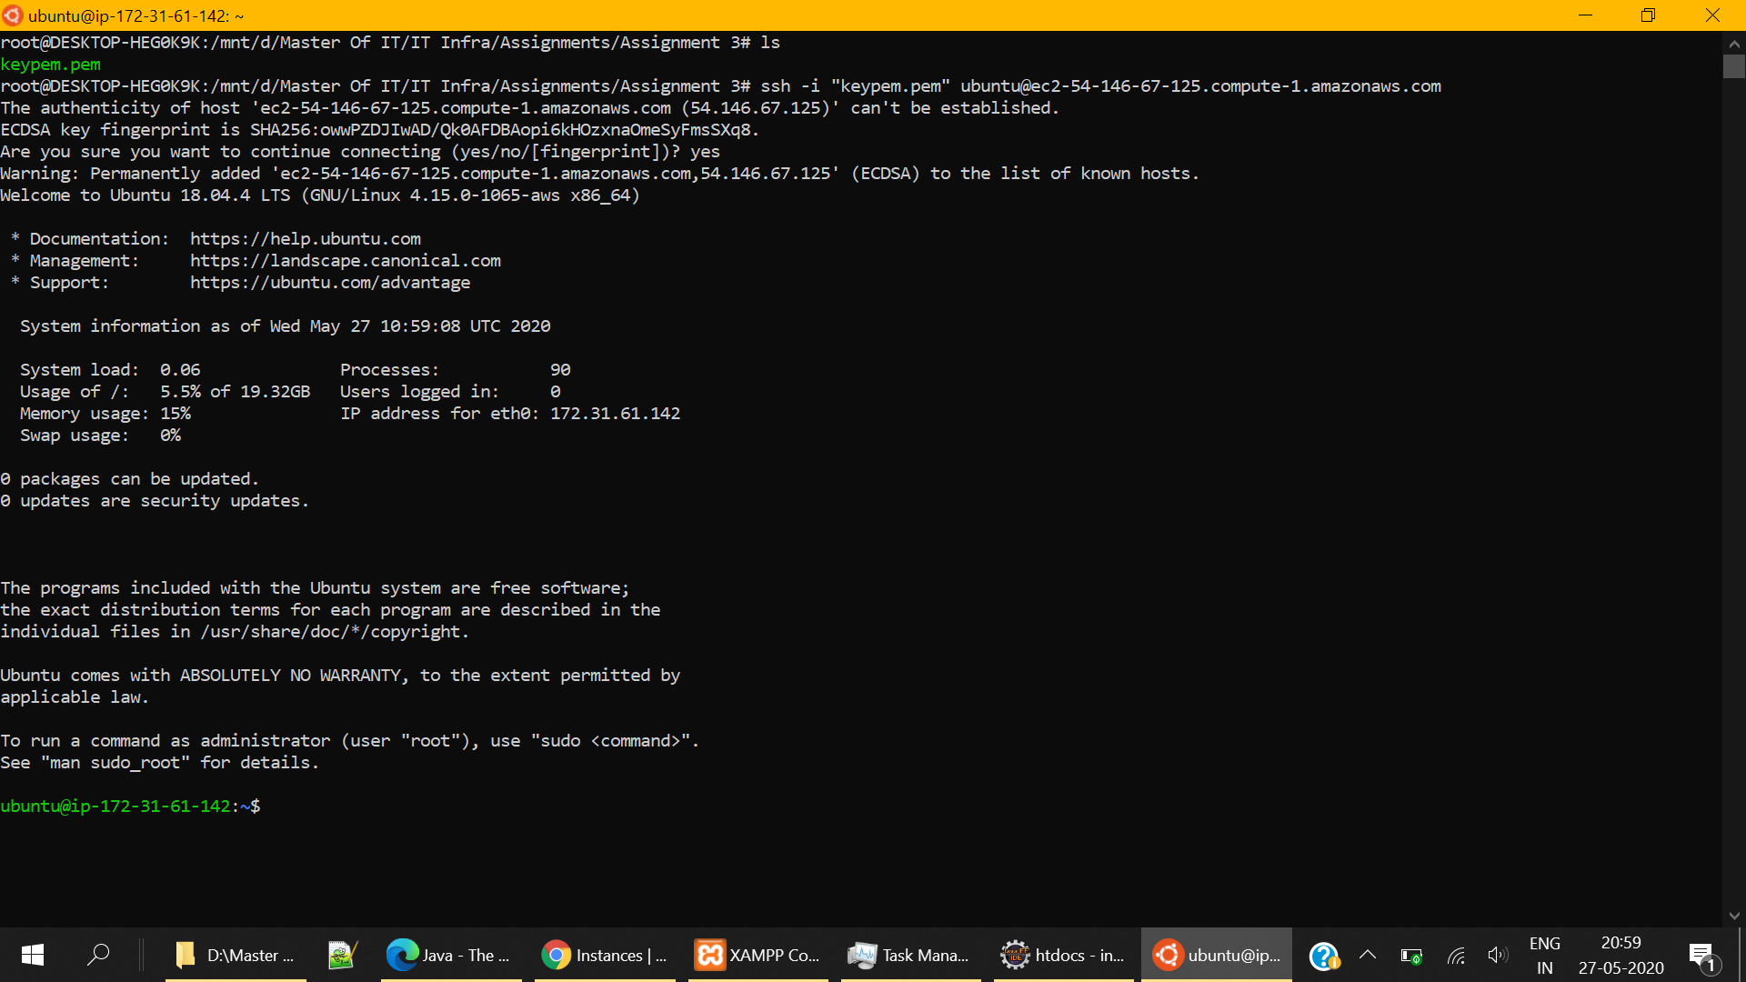

**1.4 EC2 – Preparing Application Environment:**

1. First update & upgrade all the existing packages   
   sudo apt update  
   sudo apt-get upgrade

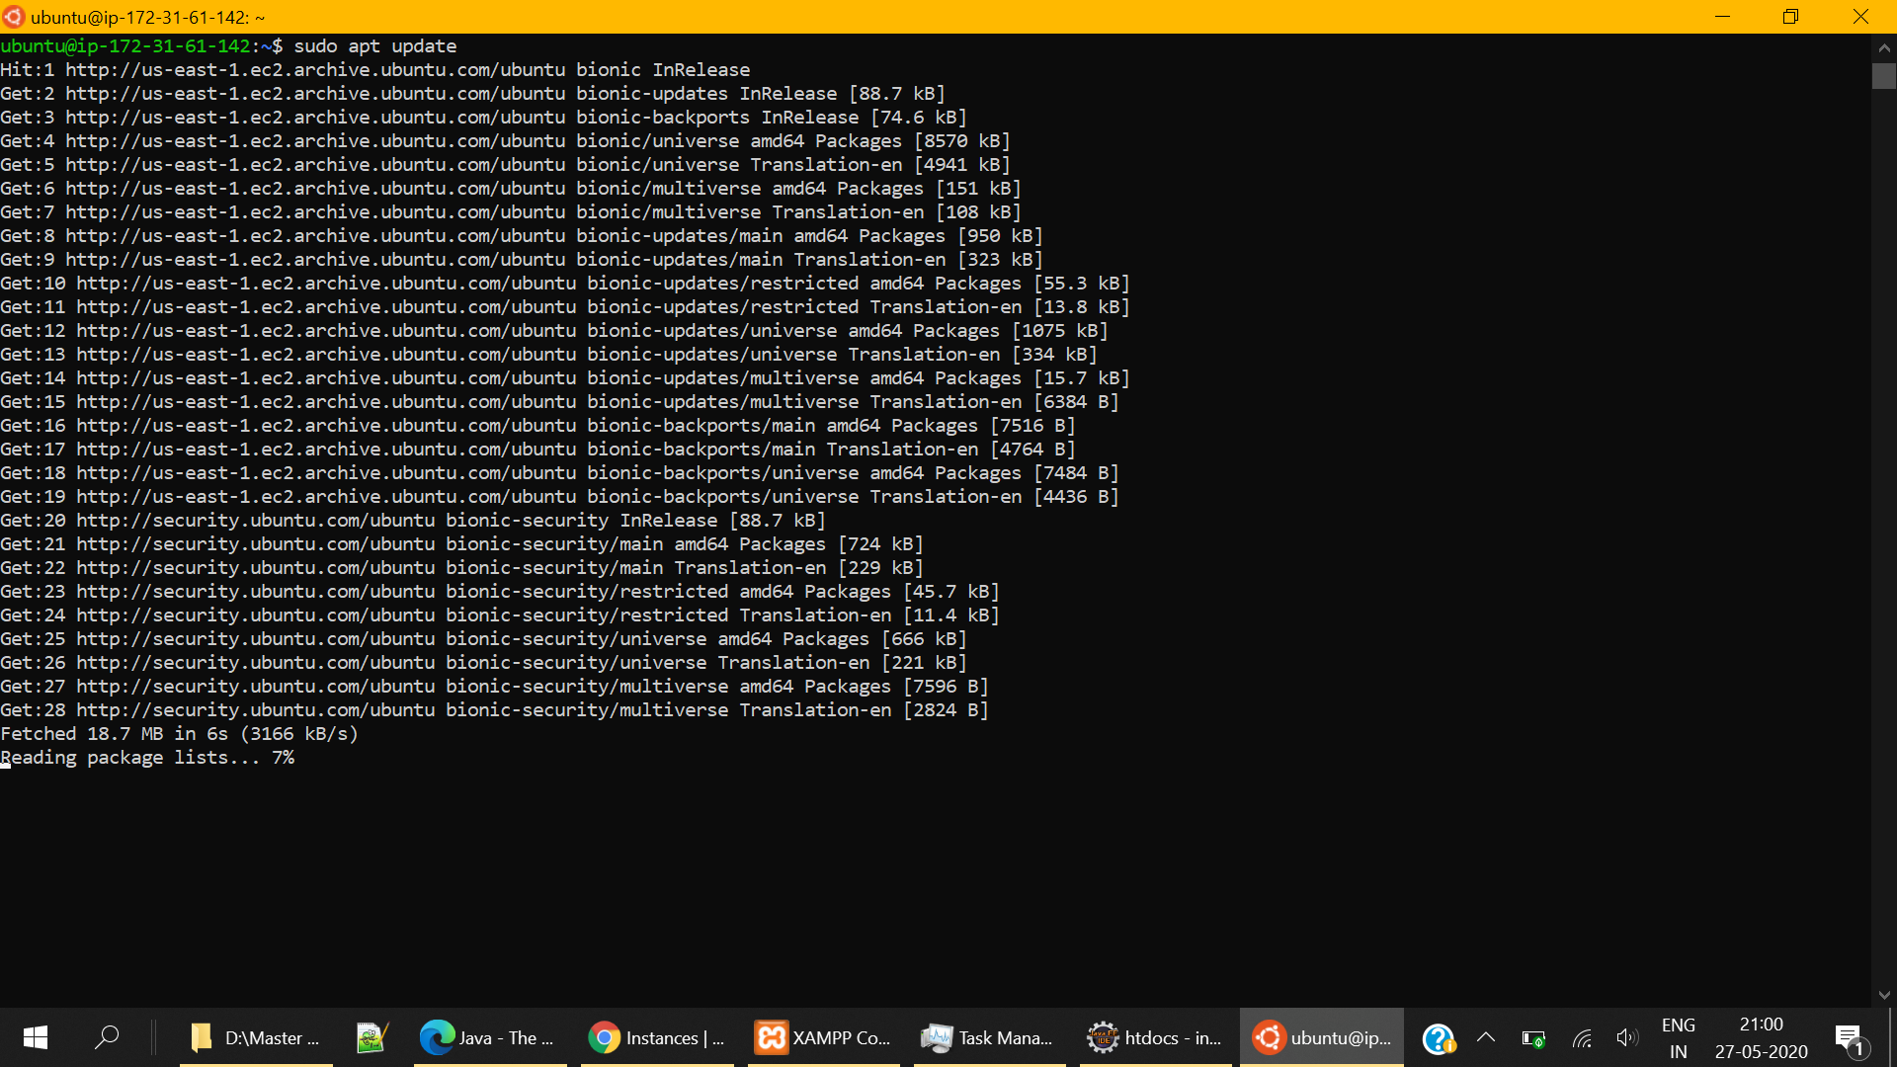

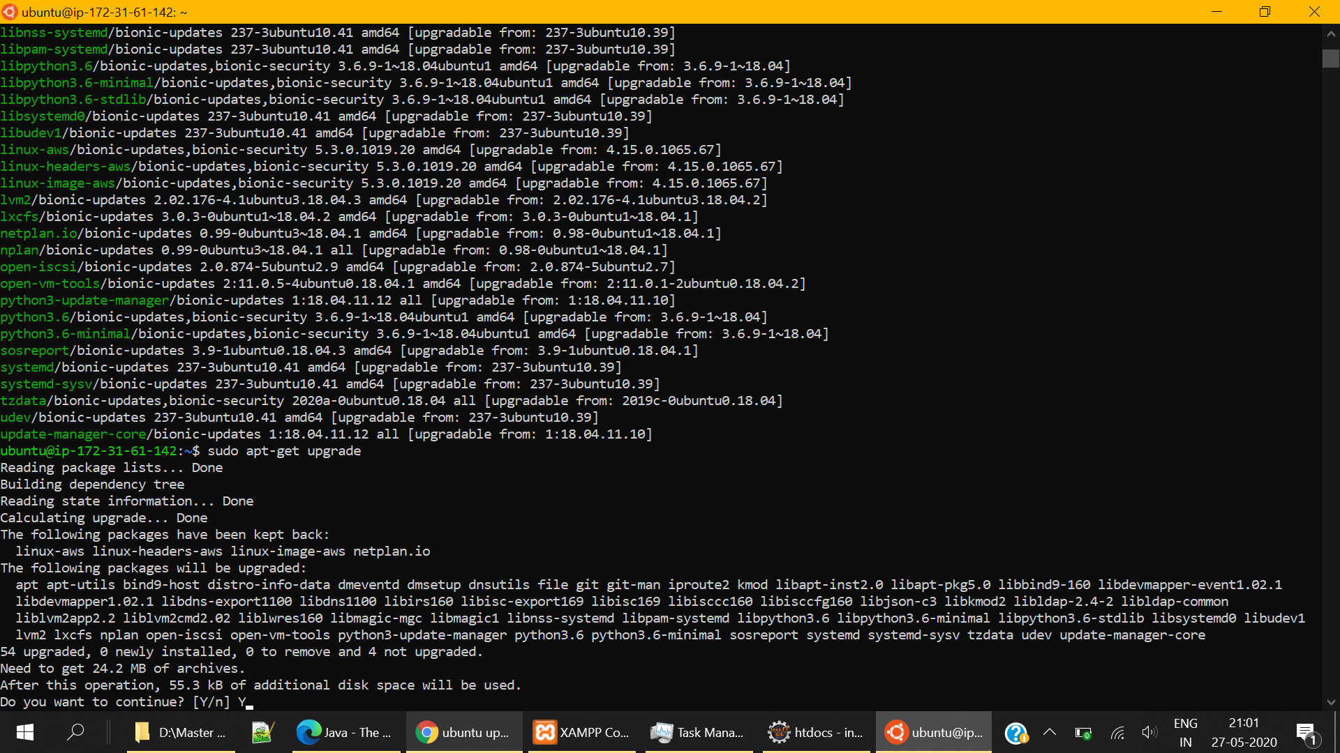

Let’s install additional required packages on EC2 instance which includes,

1. Apache Web Server  
   sudo apt install apache2
2. PHP  
   sudo apt-get install php libapache2-mod-php   
   sudo a2enmod mpm_prefork
3. Verify installation using  
   php -v

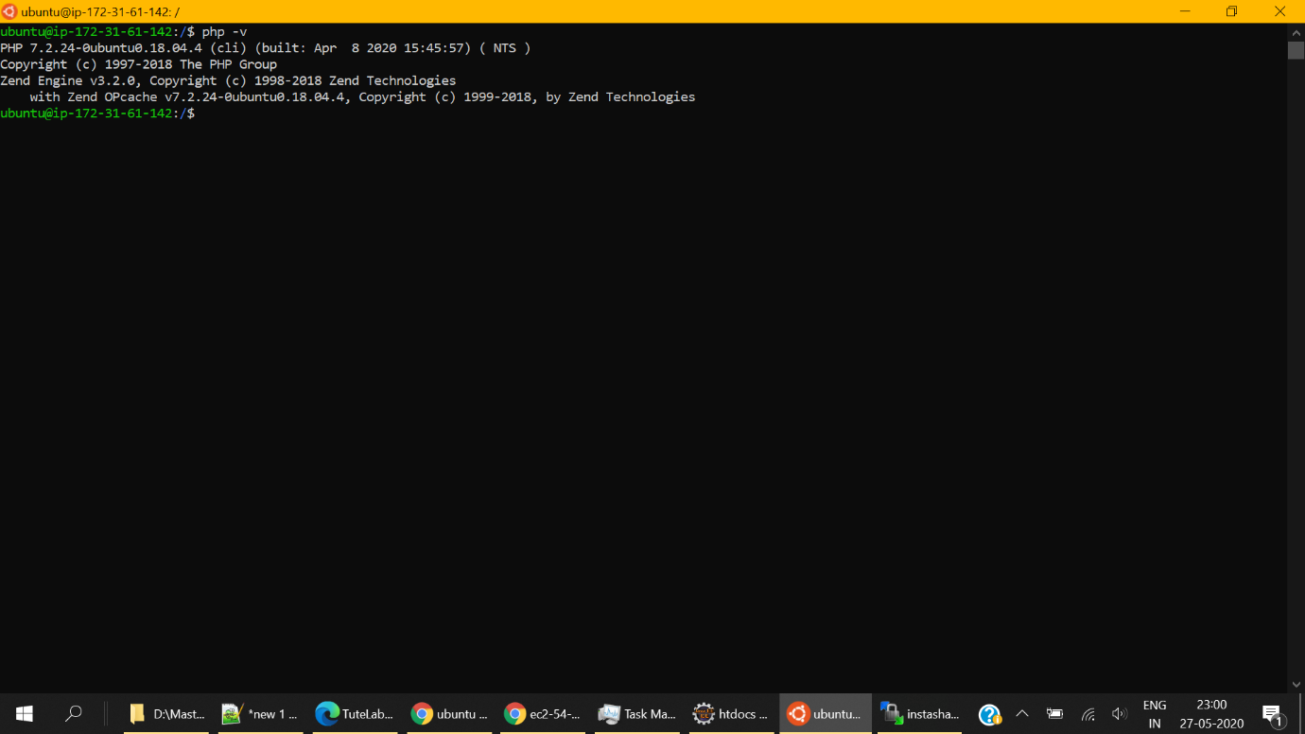

1. cURL  
   sudo apt install curl
2. PHP-cURL  
   sudo apt install PHP-curl
3. MySQL driver  
   sudo apt-get install php7.2-MySQL  
   sudo phpenmod mysqli  
     
   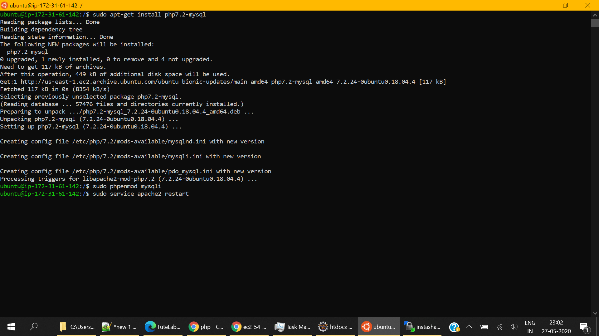
4. Change permissions of var/www/html folder to 0755  
     
   sudo chmod 0755 /var/www/html
5. Start Apache server  
     
   sudo service apache2 start
6. To restart already running server use  
     
   sudo service apache2 restart
7. To know the status of apache service use  
     
   sudo service apache2 status  
   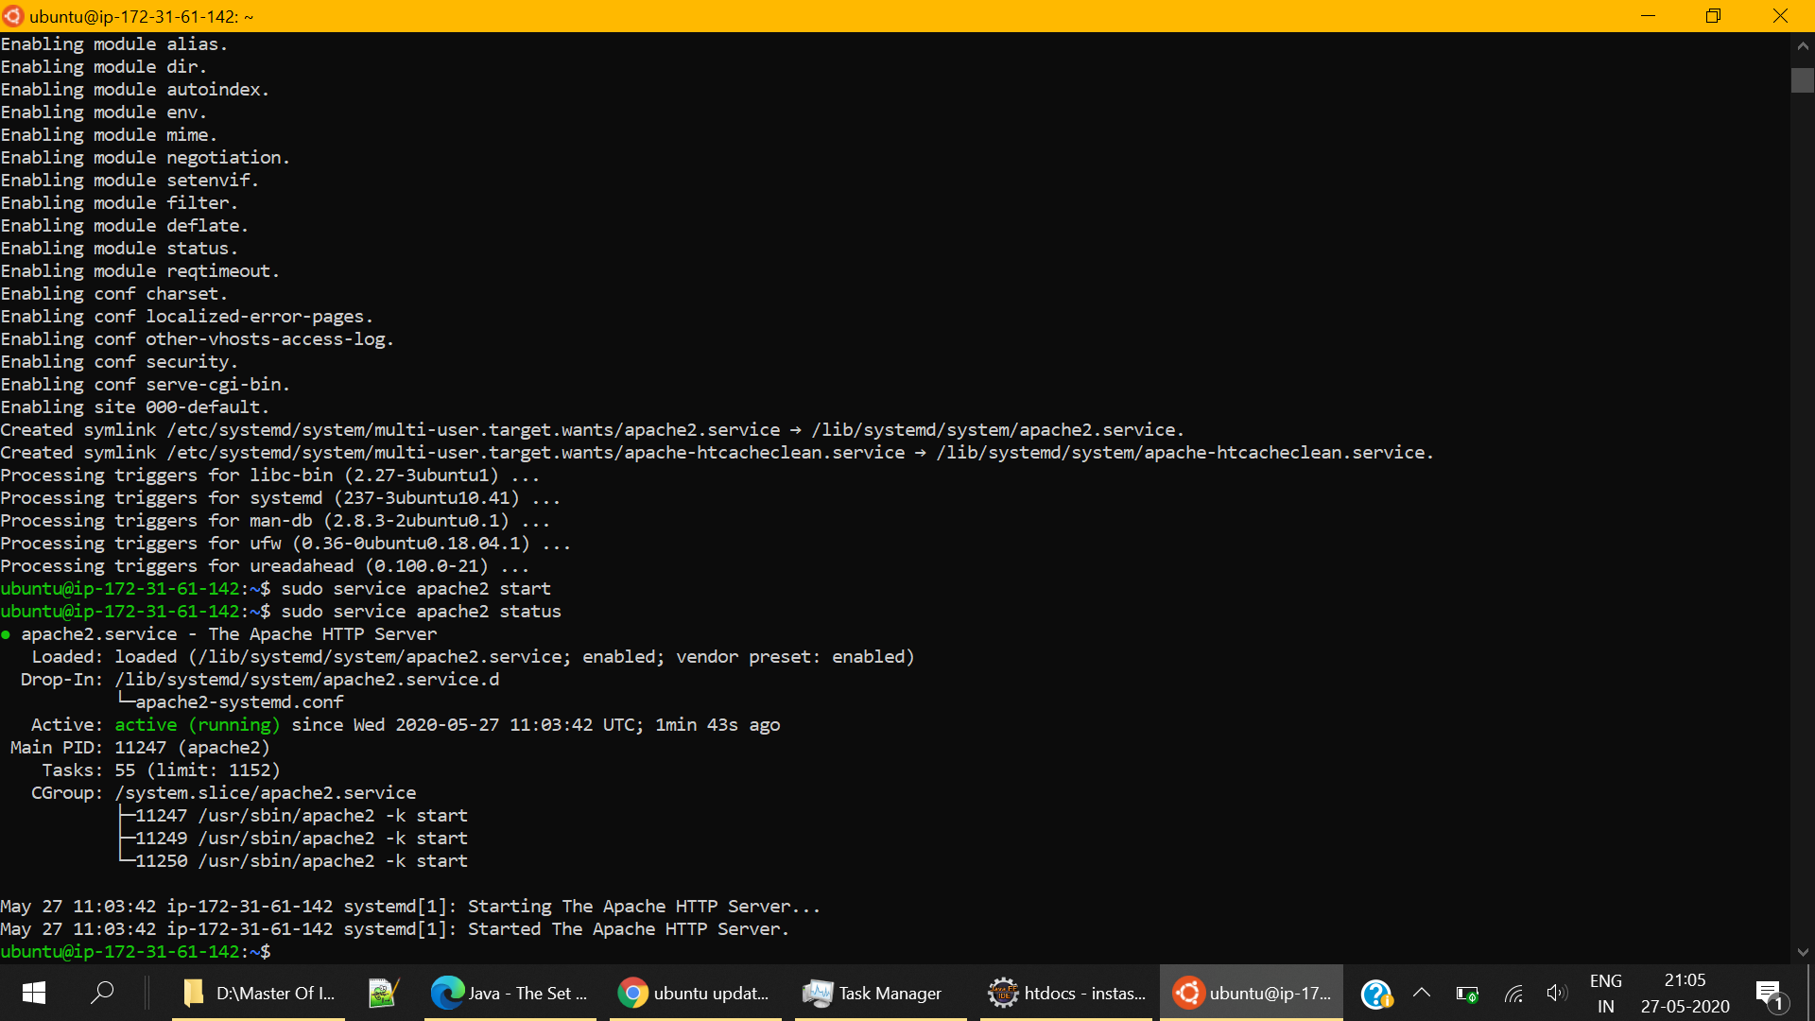

**1.5 Uploading Application Folder**

**Creating Private Key for WinSCP**

For windows machine, we will be using WinSCP for uploading application files to EC2 instance

1. Download WinSCP from –

<https://winscp.net/eng/download.php>

1. After opening WinSCP, it will automatically ask for site details.  
     
   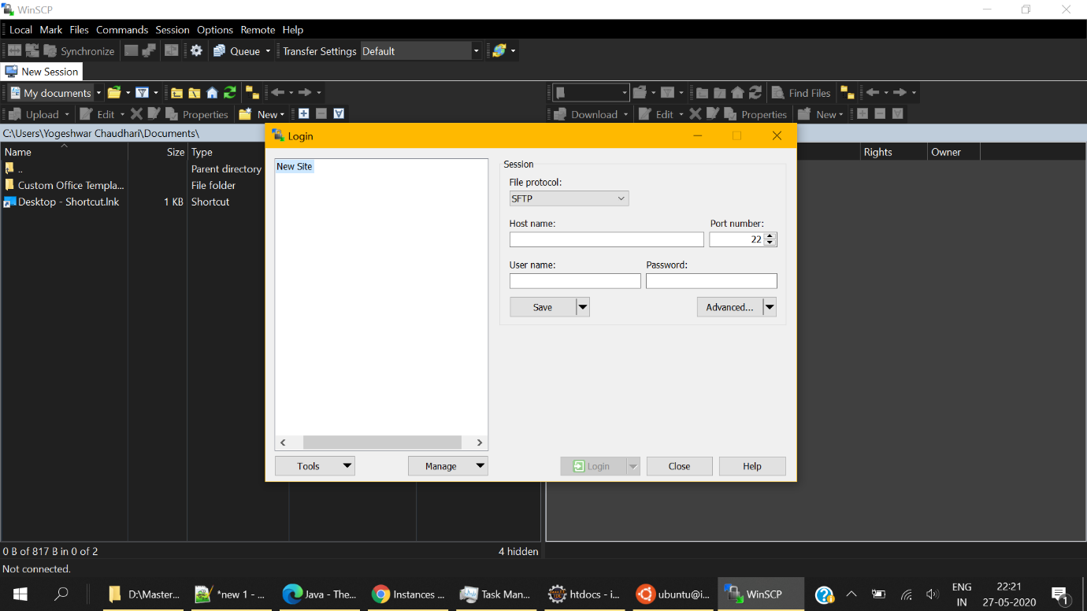
2. Click on Tools -> Run PuTTYgen

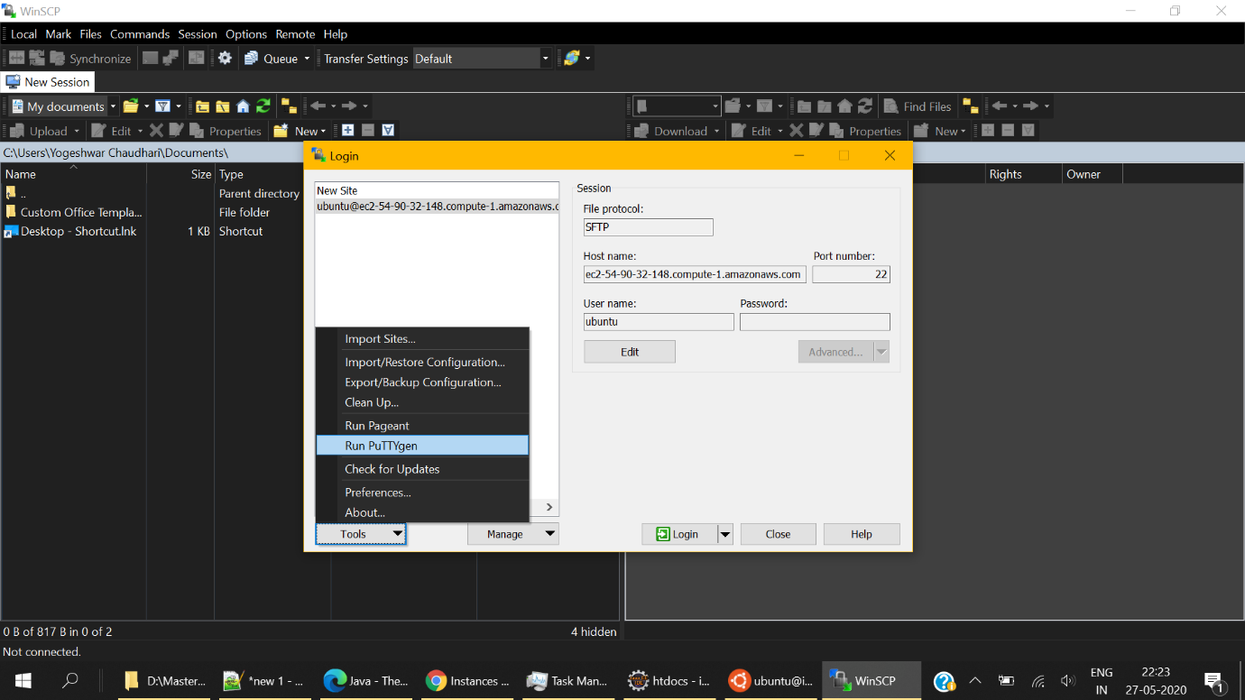

1. 1. Select RSA as a type of key to generate

2. Load the key-pair that we generated for EC2 instance using the “Load” option  
3. PuTTYgen notice will appear as shown below. Proceed with OK

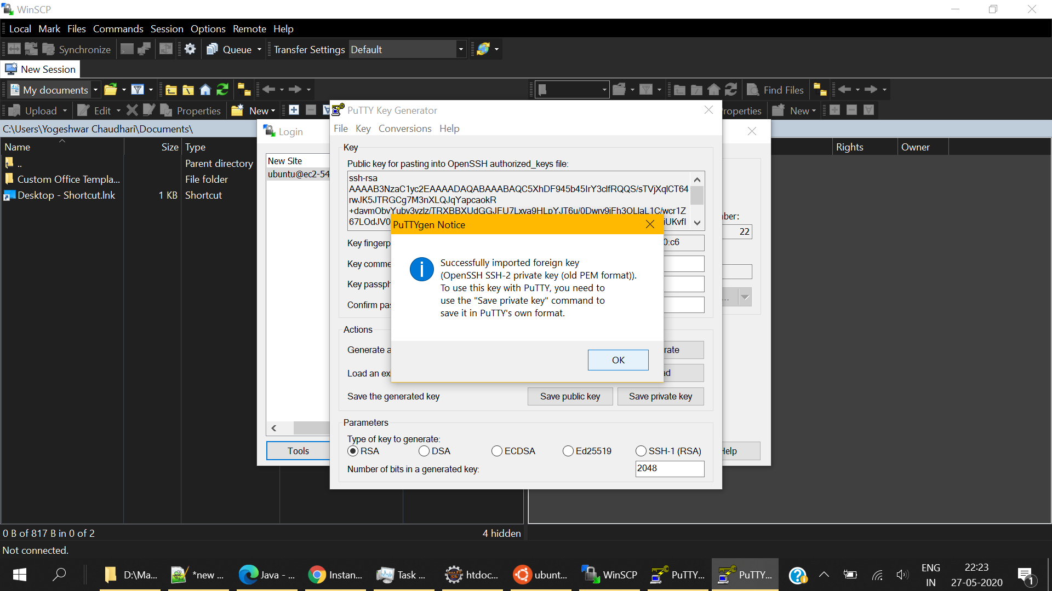

5. Click “Save Private Key” to save the .ppk file which will be used by WinSCP  
6. Click Yes to save the key without paraphrase.

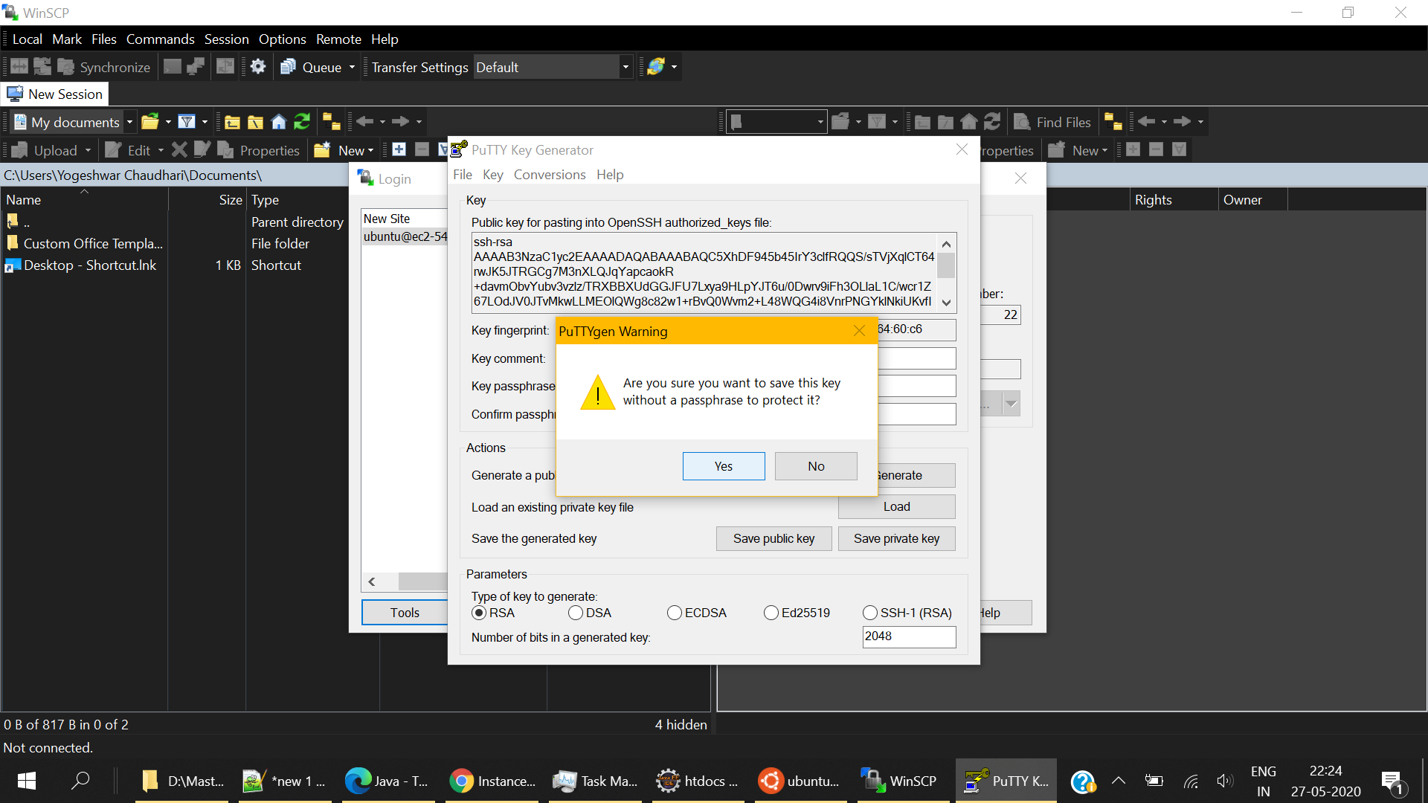

7. You will now see the main WinSCP site window.

**Connecting using WinSCP**

1. Select the EC2 instance and its details will be shown in the below window.   
2. Copy the public DNS this is your hostname for WinSCP

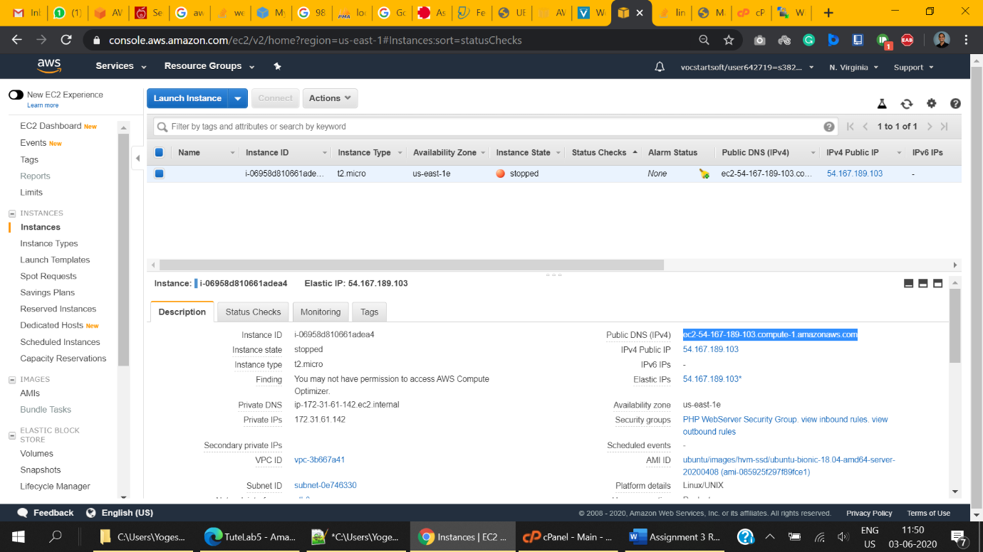

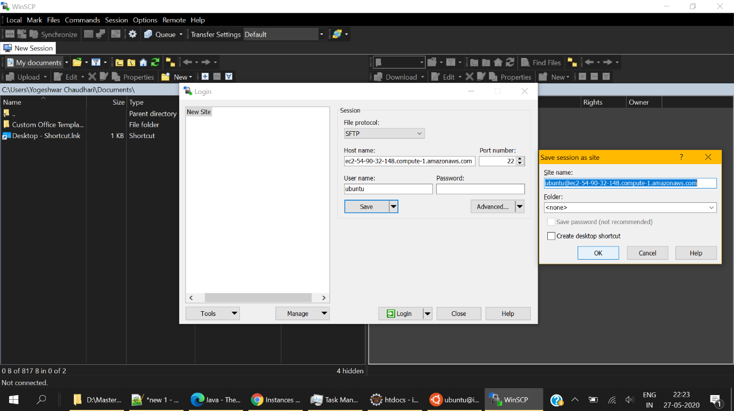

1. Enter username as ‘ubuntu’ for ubuntu installations and leave everything else to default
2. Click “Advanced” to open “Advance Site Settings”
3. Select SSH -> Authentication from left options
4. Under Authentication Parameters -> Private key file, Browse and load the private key file we created using puTTYgen. (It will have .ppk extension)
5. Hit OK

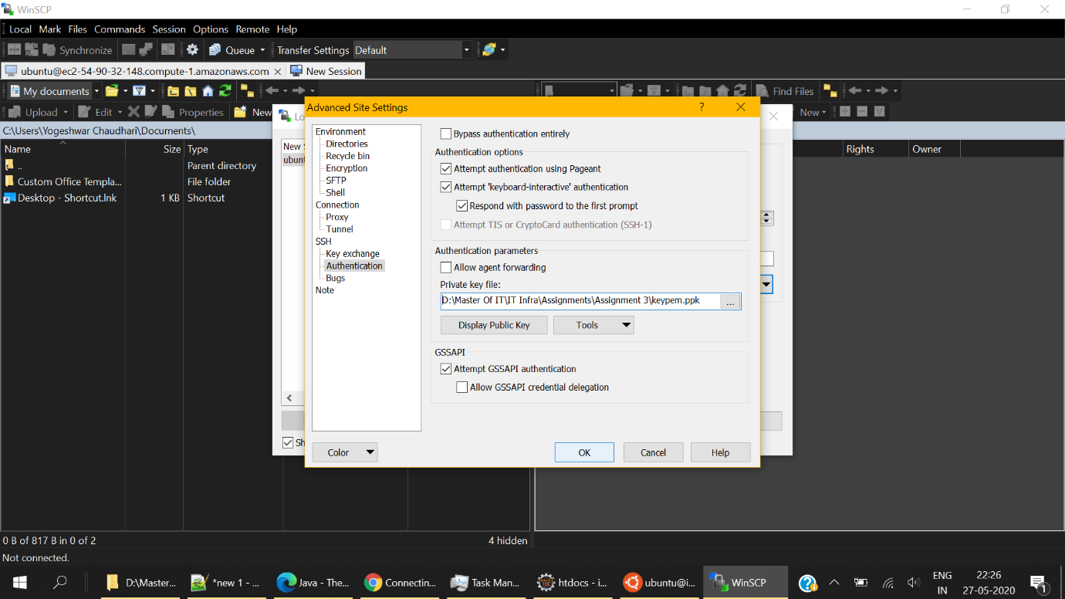

1. Hit Login to gain access to EC2 server files.  
   On LHS you can see files on your local machine.   
   On RHS you can see files on your EC2 instance.
2. Move to /var/www/html in RHS i.e. EC2 instance
3. In LHS, navigate to the provided zip folder of the application. Simply drag from left window to right window to upload.   
   **\*Uploading individual files might take a considerably longer time. Hence it is advised to upload the zip file only and extract it on the server.**
4. Go to /var/www/html from terminal and unzip the contents using  
   sudo unzip <name_of_zip_file>
5. If unzip is not already installed on your instance, use the following command to install it first and then run the above command again.  
   sudo apt-get install unzip
6. Your /var/www/html should appear as given below –   
     
   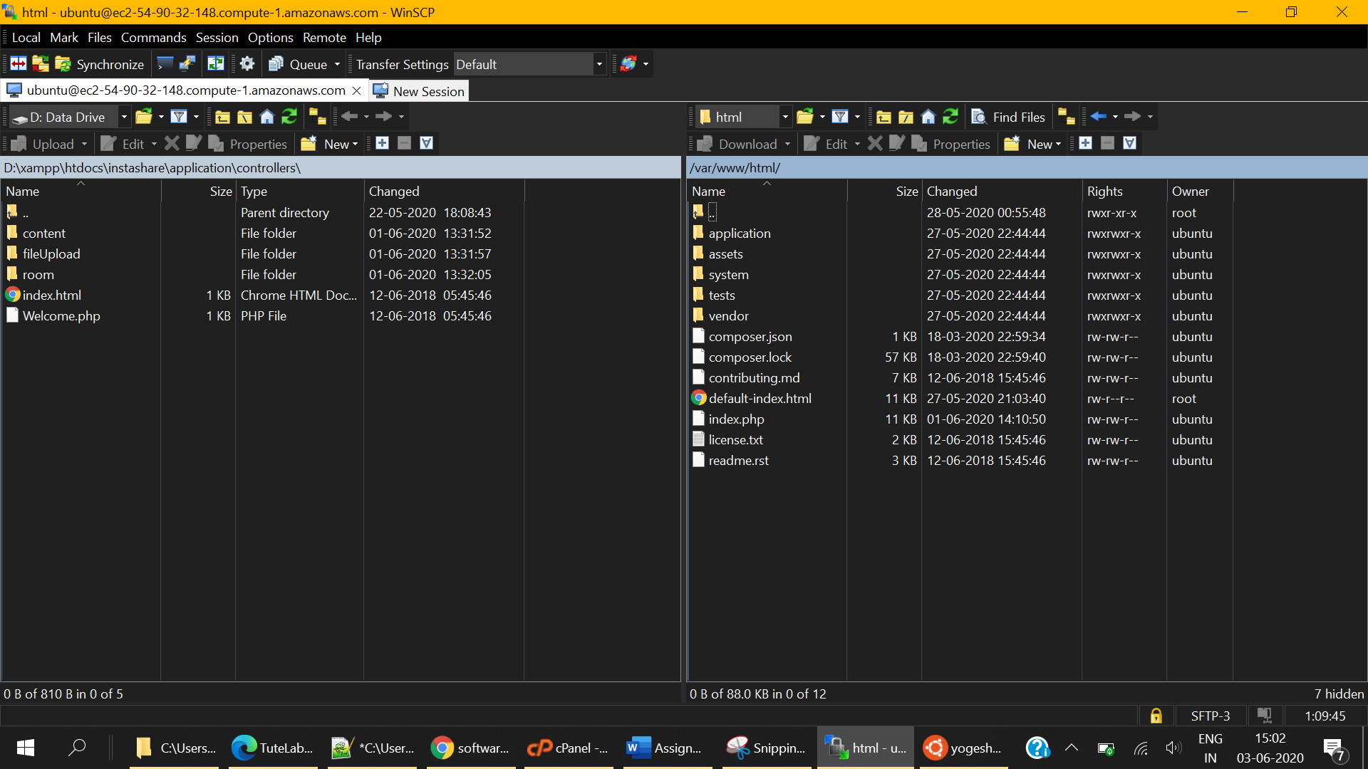
7. The next steps can be performed after creating a database. Please remember where we left.

**2. Creating S3 Bucket**

Locate (Simple Storage Service) S3 under Storage Services in AWS services.  
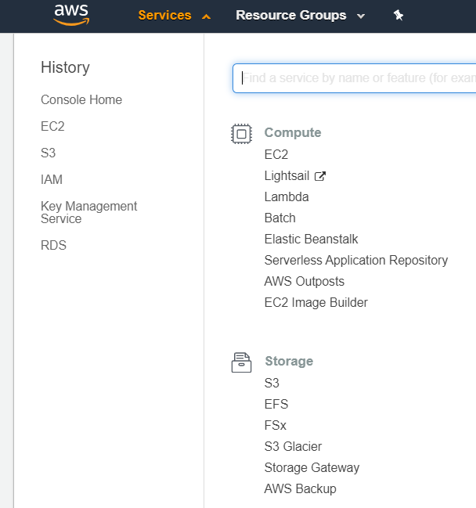

1. Click Create Bucket
2. Provide Bucket Name e.g. instashare-database-backup-bucket
3. Create (Bottom Left Corner)

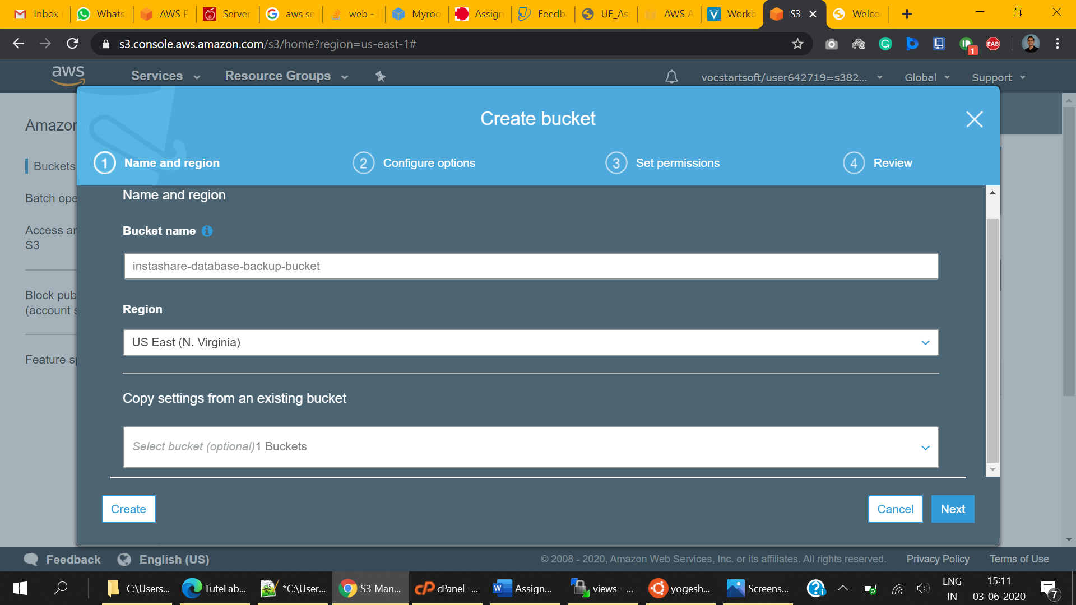

Congratulations! You have successfully created a bucket. We will be using this bucket for storing database snapshots. That’s why we have blocked all the public access to it.

**Database Setup**

Creating database

1. Select AWS Service -> Database -> RDS
2. Click on “Databases” from left options or Click on “DB instances” from Dashboard  
     
   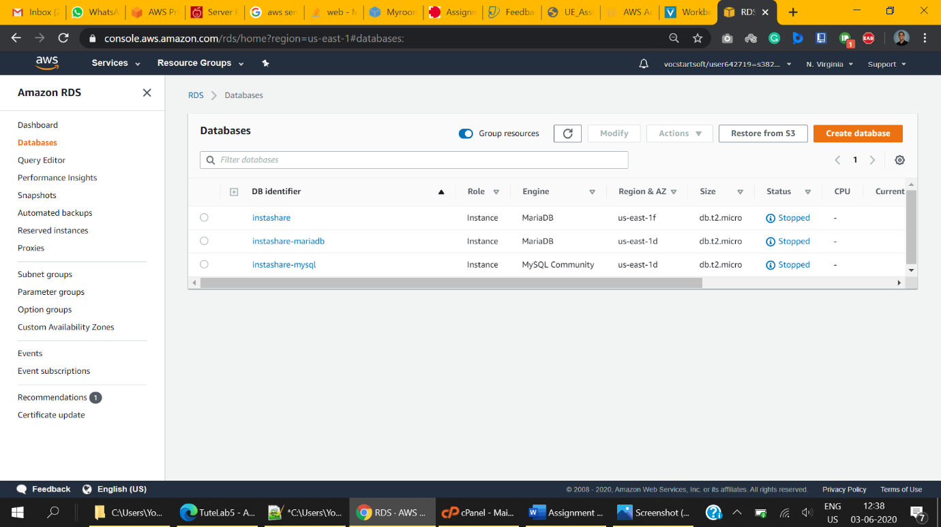
3. Hit Create Database.
4. We are using MariaDB for this application.
5. Chose Standard Create and select **MariaDB** as Engine Type  
     
   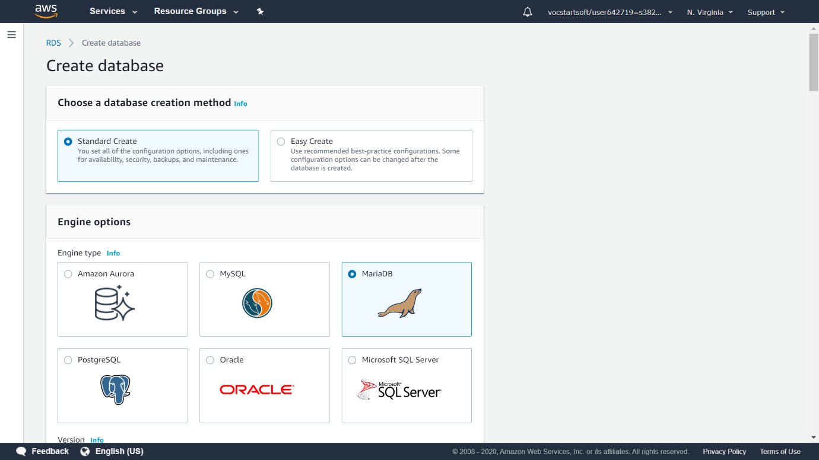
6. We are using free tier services for development purposes.  
   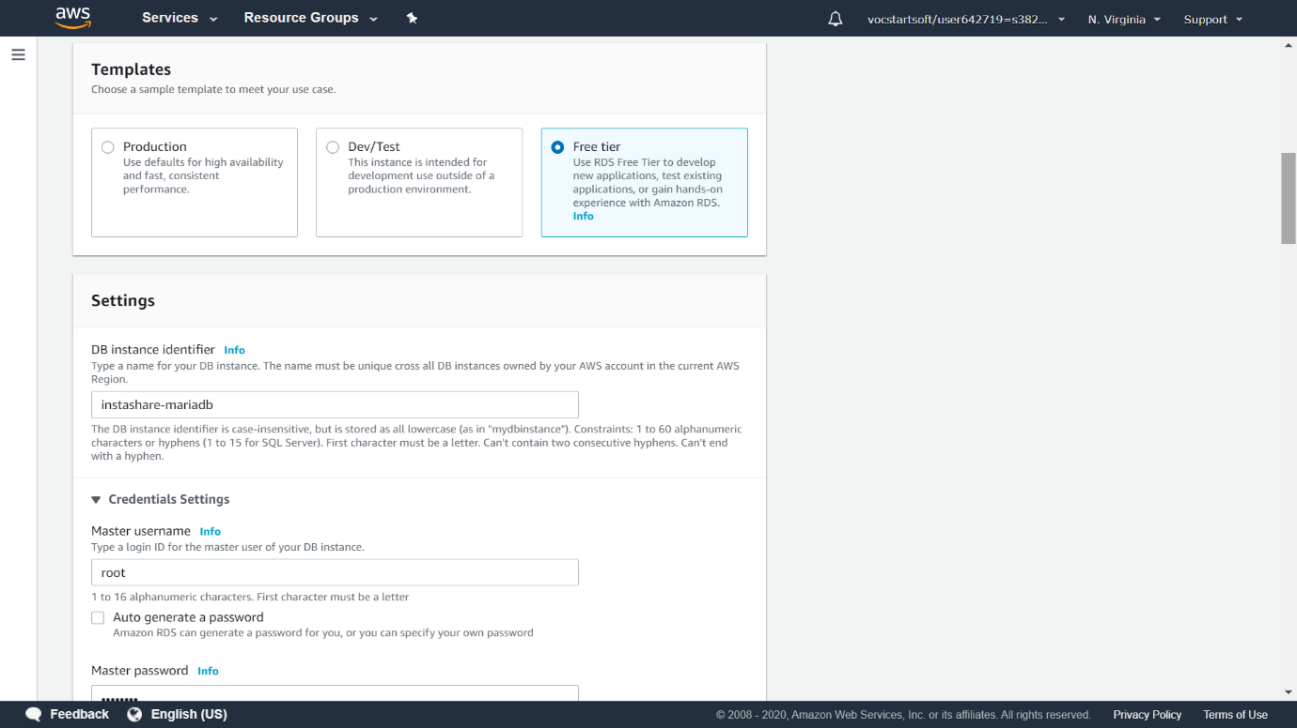
7. 1. Provide a DB instance name for this instance.  
   2. Provide Master username and Password.   
   **\*Take a note of this master username and password as we will require to supply this to our application to connect to this DB instance.**



1. Chose DB instance size. I have chosen db.t2.micro  
     
   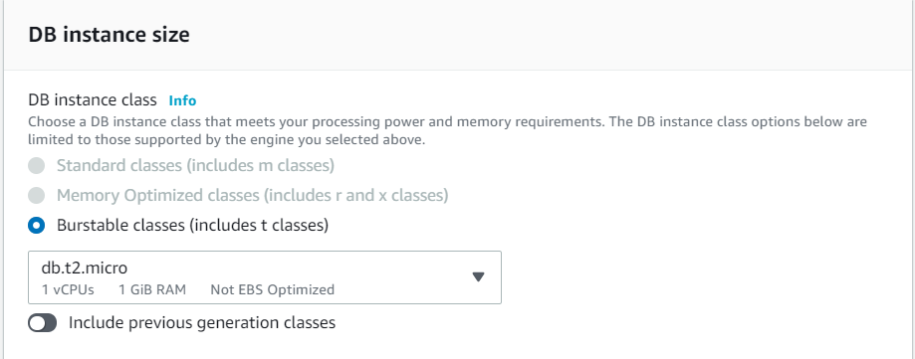
2. Select Storage.  
     
   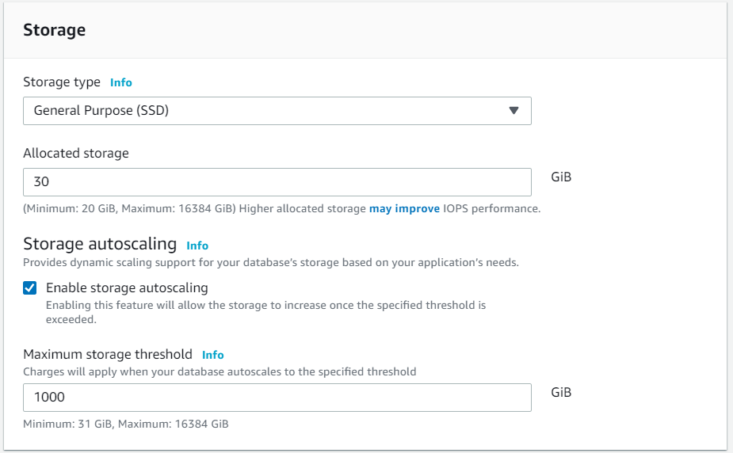
3. Change the accessibility settings to **Publicly accessible.**   
   **(This is only for the assignment purpose. In the production environment, you will possibly choose to the accessibility of DB instance only to EC2 instances within the same VPC group.)**  
   Make sure that the default VPC group is selected.  
   Database port must be 3306  
     
   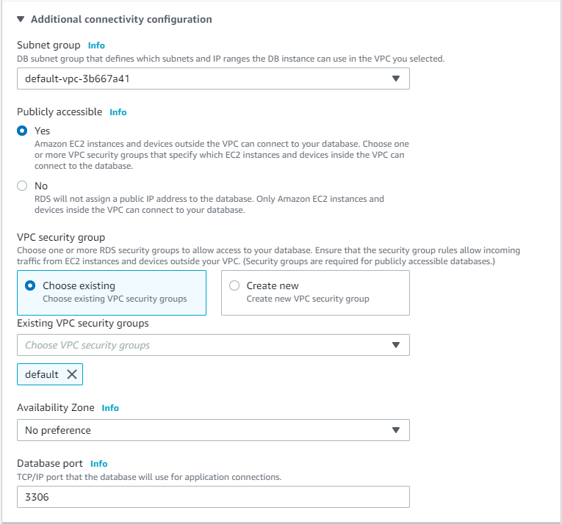
4. Expand the additional configuration

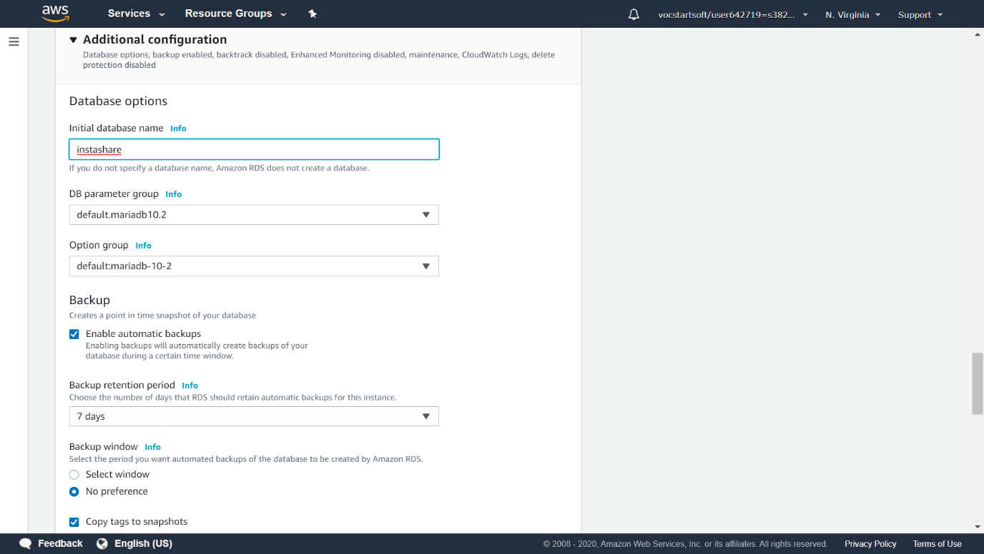

* 1. Provide the initial database name. This will create a database for use with the provided name.
  2. Take note of the database name. Database name can also be retrieved from the RDS console -> List of DB instances -> Click <db-instance name> -> configuration Tab -> DB name
  3. If you forgot to this step, then you need to create a database manually using the following command -  
     create database <database>;
  4. Leave everything else to default.
  5. Hit “Create Database Command”

1. Creating a new database instance might take time. Please wait until instance state changes to Available.
2. Take note of Endpoint of the instance  
     
   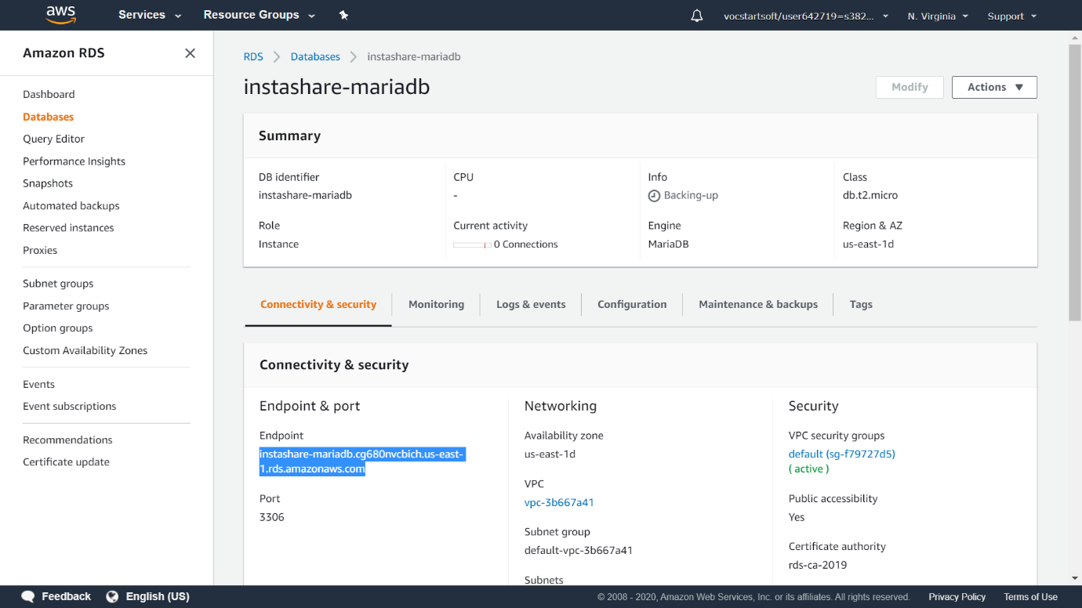

Making DB instance accessible from EC2 and LocalHost

1. Click on the DB instance which you will be using for this application.
2. Find VPC security Groups under Connectivity & Security (Tab) -> Security (Heading)
3. Click on the Associated VPC security group. (default in our case)

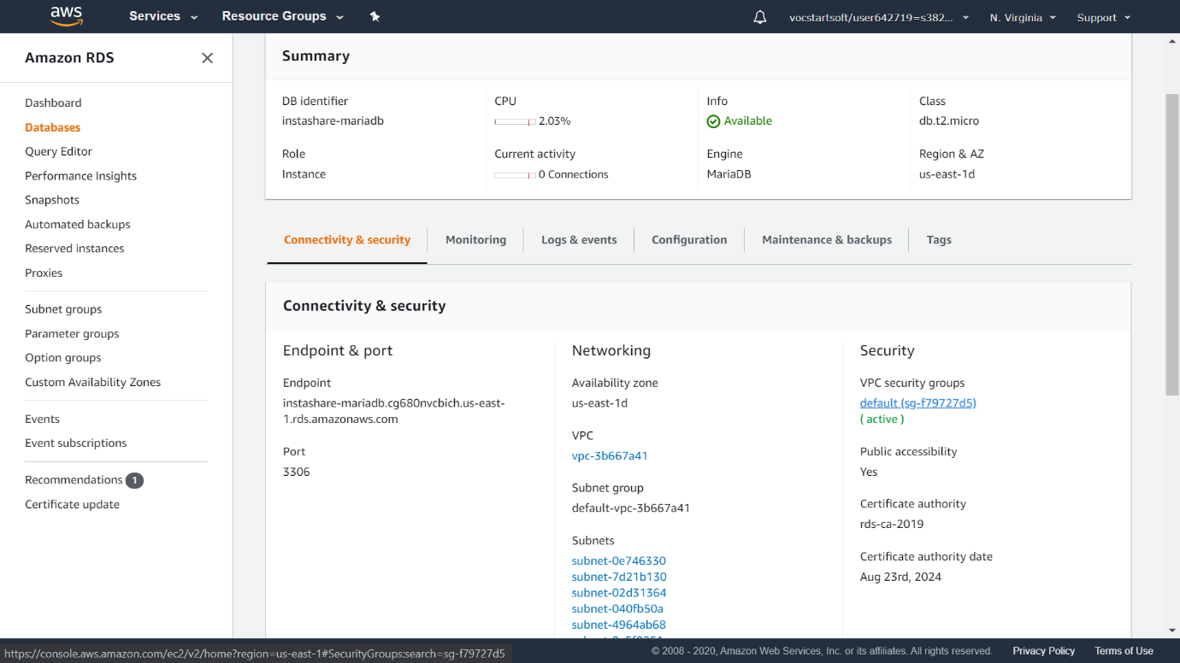

1. On clicking security groups, you will be redirected to EC2 -> Security Groups  
     
   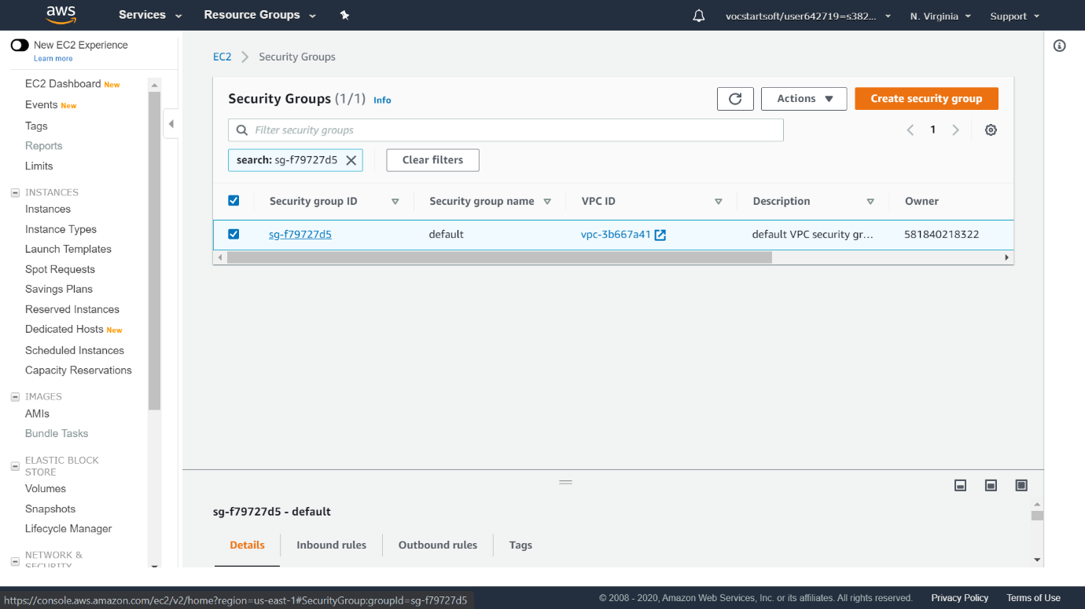
2. Click on the associated security group to see the details.   
     
   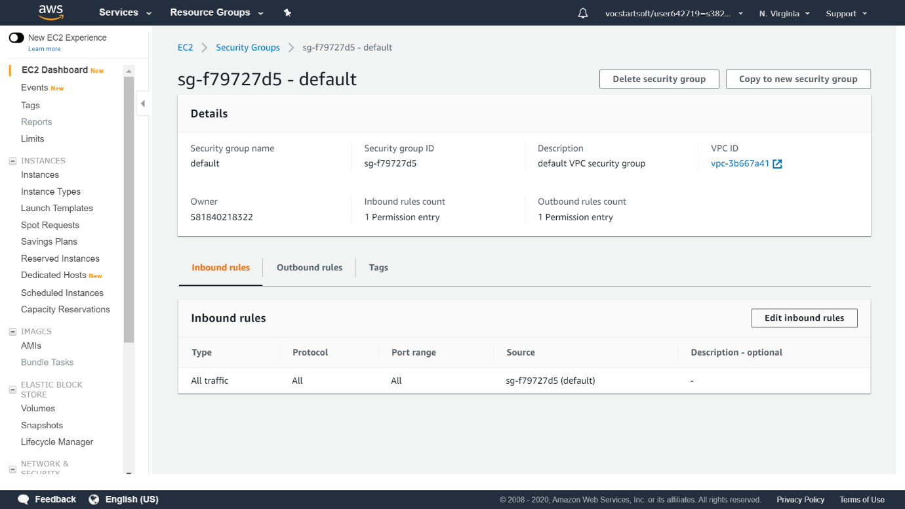  
     
   Click on Edit Inbound rules to change the rules
3. Add rule
   1. **Type**: All Traffic
   2. **Source**: Anywhere
   3. **Description**: Provide an understandable description so that other people can also understand the purpose of the group.
   4. After making all changes, your inbound rules should appear as given below.
   5. Validate and click on Save Rules.

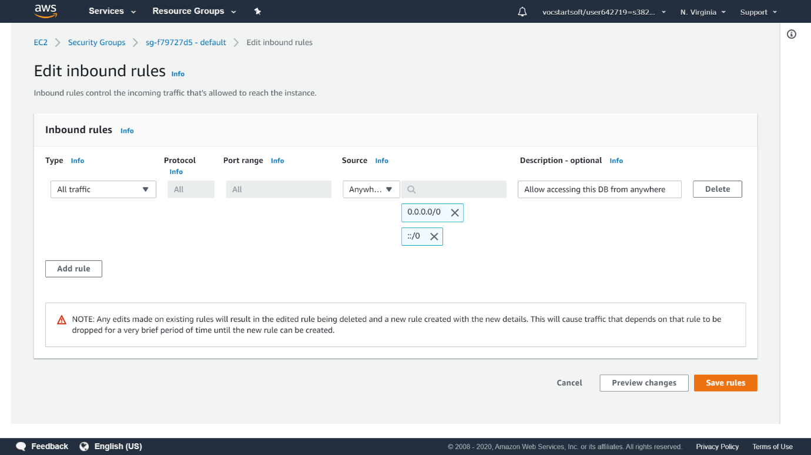

1. Go to Databases and reboot your instance to apply changes.  
     
   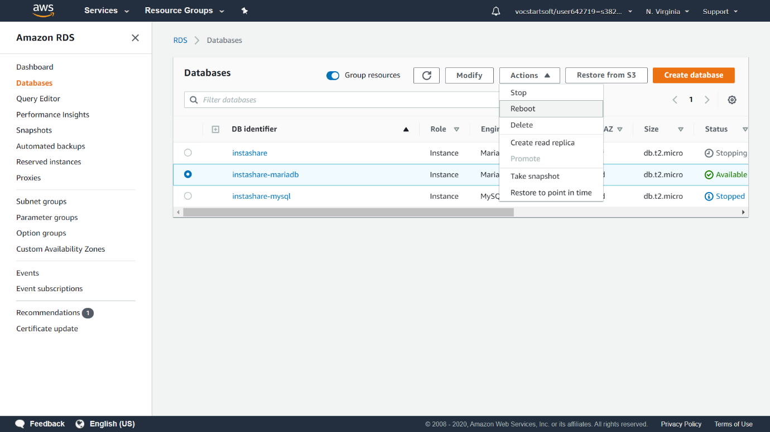

Creating Required Tables

1. Install MySQL client for Ubuntu terminal (on your local machine or instance) to connect to DB instance. I am installing this on my local ubuntu machine.
   1. Install MySQL client using the following command -  
      sudo apt-get install mysql-client  
        
      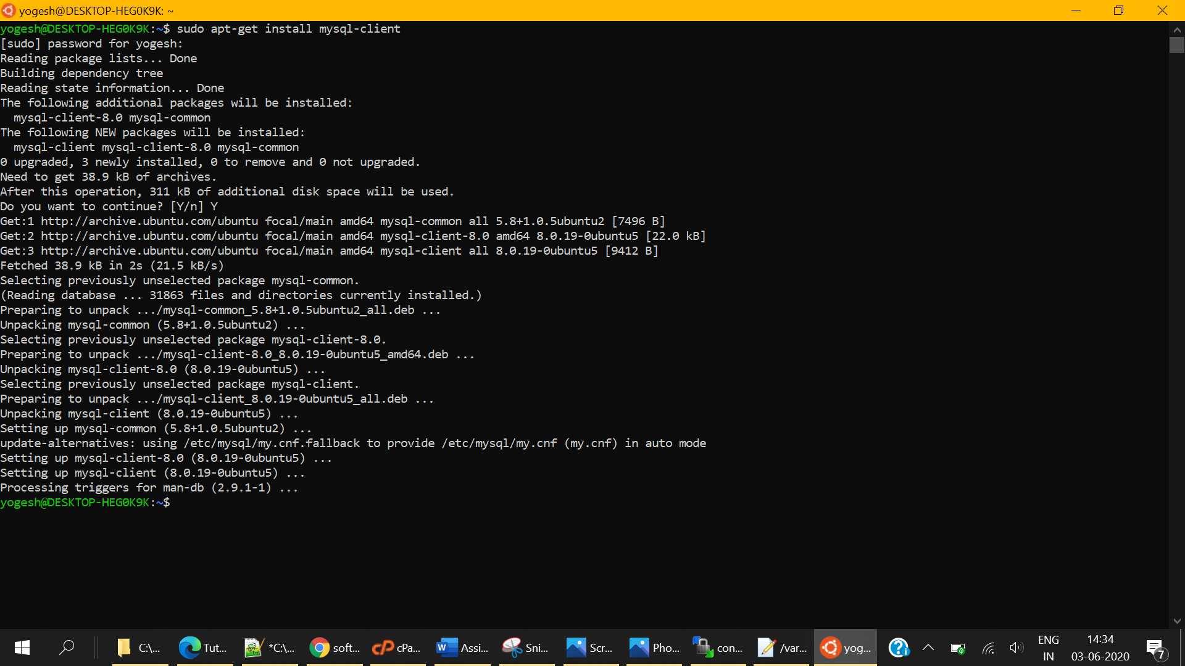
2. Connect to DB using Terminal  
     
   mysql -h <your-db-host-name> -P <port-number> -u <username> -p

mysql -h instashare-mariadb.cg680nvcbich.us-east-1.rds.amazonaws.com -P 3306 -u root -p

1. You will be asked to enter the password. Enter the master password to connect that we supplied while creating a user for DB.  
   After a successful connection, you should be able to see the following screen.  
     
   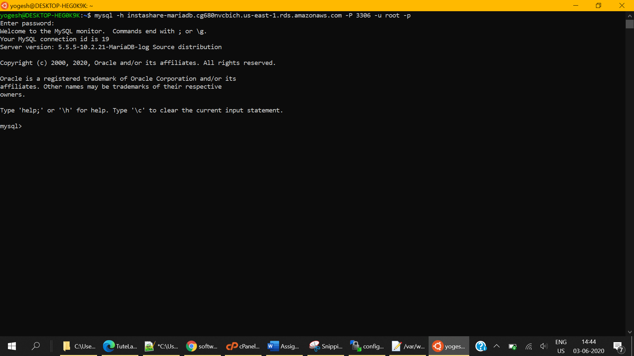
2. Create script has been provided in the Database Folder  
   Locate “Database/Table Create Statement.sql” and follow the instructions;  
     
   *Remember that you have already created the database while creating the DB instance. Switch to the database using USE <database-name>; command  
   * In case you have omitted to create a database, create a new database using CREATE DATABASE <database-name>; and then switch to the new database using USE <database-name>; command
3. Execute every statement one by one.   
   **\*CTRL + V will not work on ubuntu machines. Right-click to paste the already copied create a statement**  
   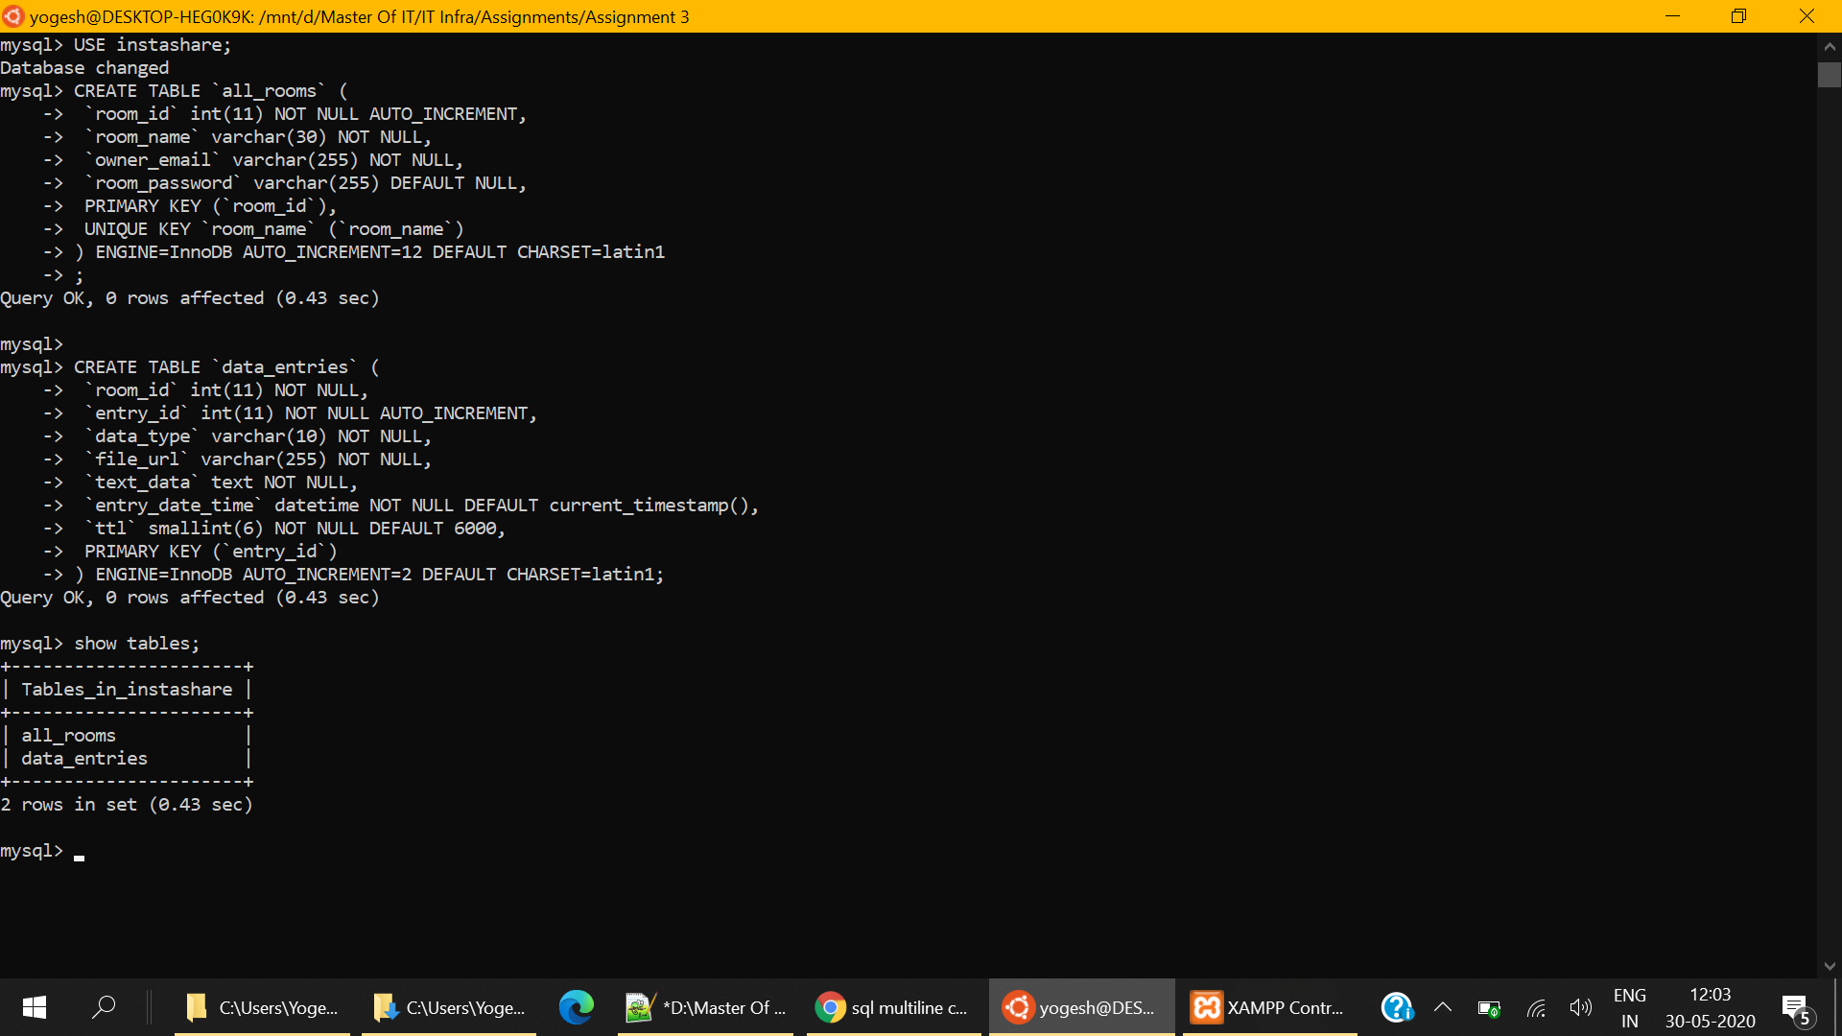
4. To list all tables,   
   SHOW TABLES;
5. To see the create statement of the table,   
   SHOW CREATE TABLE <table-name>;

Setting configuration variables in the application

Now let’s connect to EC2 using WinSCP

1. Navigate to /var/www/html/application/config folder on your EC2 instance.
2. Edit the config.php file. To edit – Right-click on the file and click on edit directly. This will open the file in your system’s default editor.

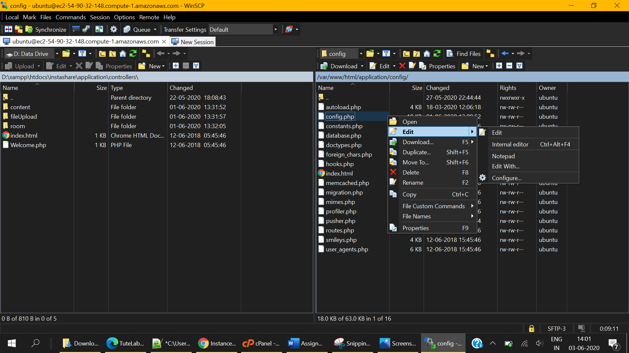

1. Enter Public DNS of your EC2 instance as base_url  
   **To save press CTRL + S**  
     
   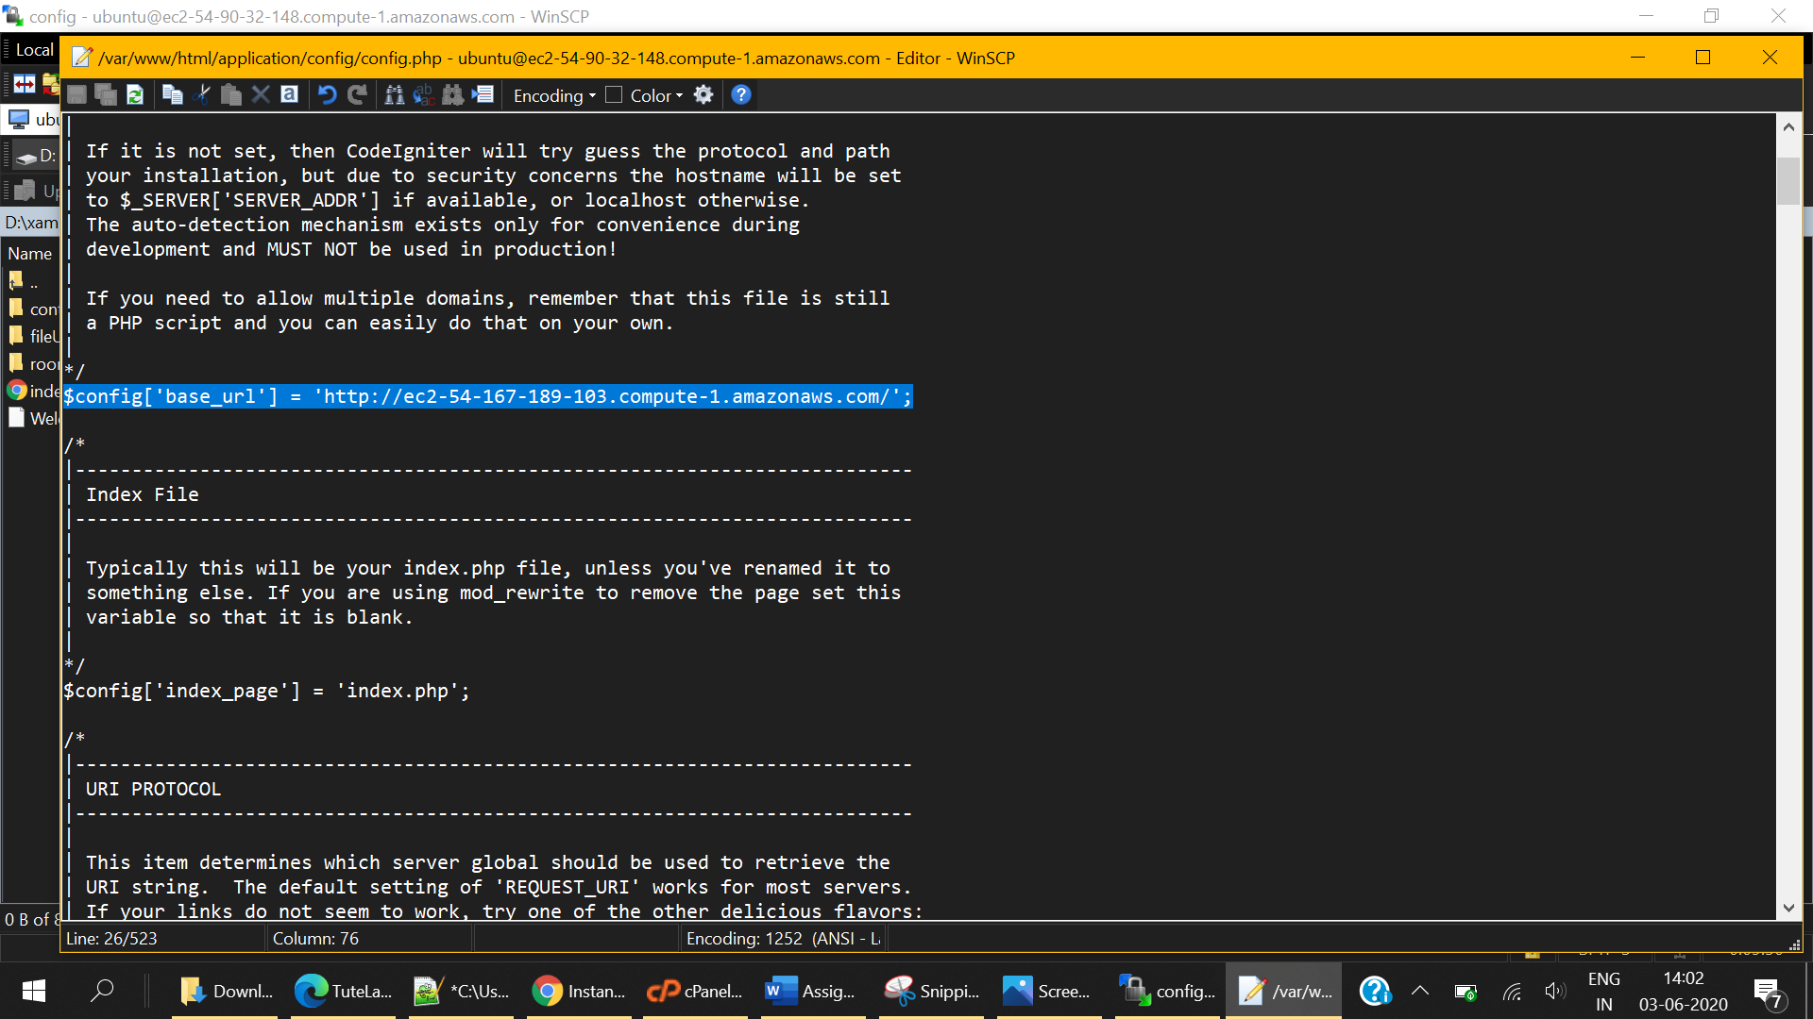
2. Edit database.php

|  |  |  |
| --- | --- | --- |
| Sr. | Attribute Name | Value |
| 1 | Hostname | The endpoint of Instance (Under Connectivity Tab in RDS console) |
| 2 | Username | Database username (Collected in earlier steps) |
| 3 | Password | Database password (Collected in earlier steps) |
| 4 | Database | Name of the database |

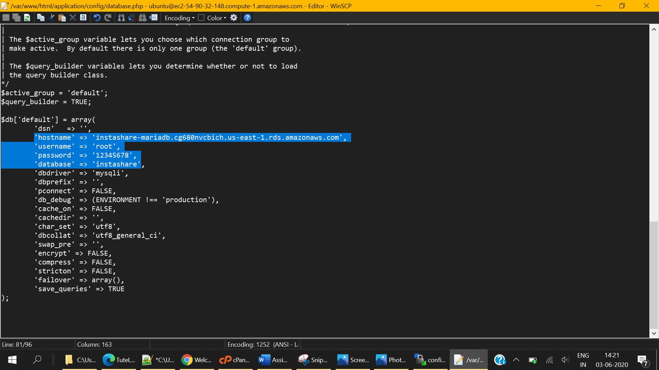

**Test Application**

Hit the Public DNS to see the application. You should see the home page of instashare  
  
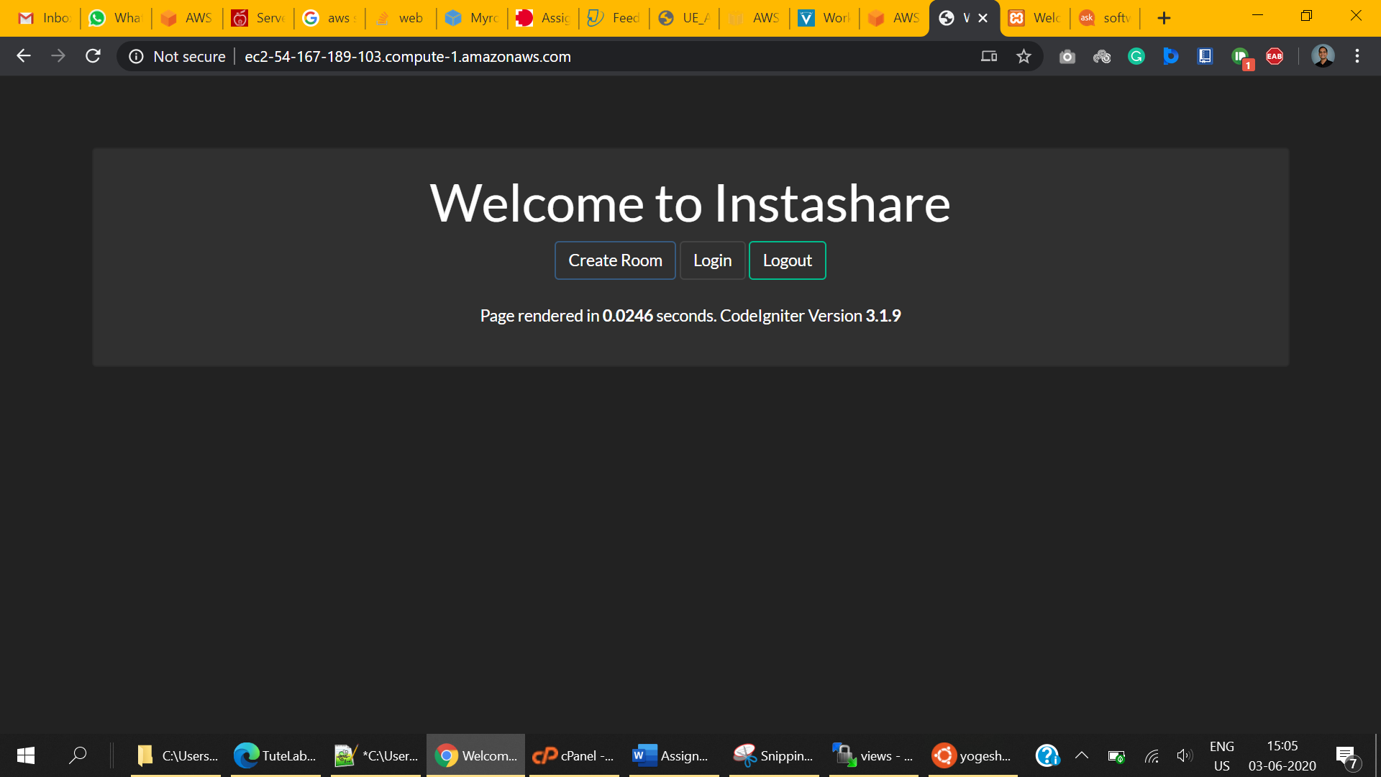

**DATABASE BACKUP**

**Creating Key for exporting-importing Database**

1. Chose Key Management Service from Security, Identity and Compliance

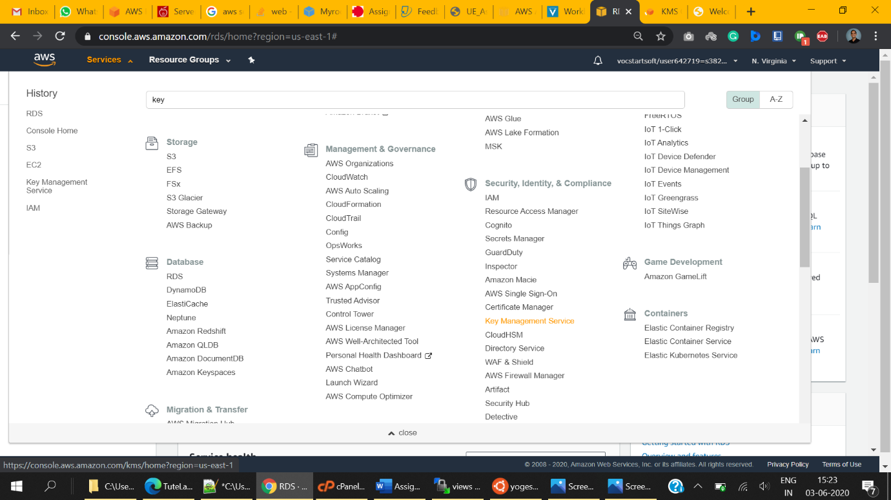

1. Under customer-managed keys, click create key  
     
   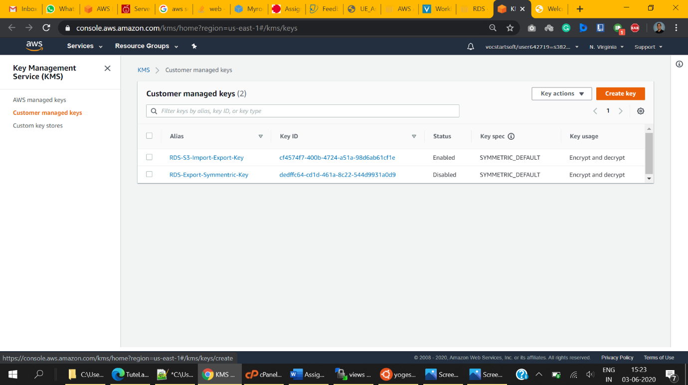
2. **Configure Key**
   1. Create Symmetric Key Type.
   2. Make sure that Key Material Origin is KMS  
        
      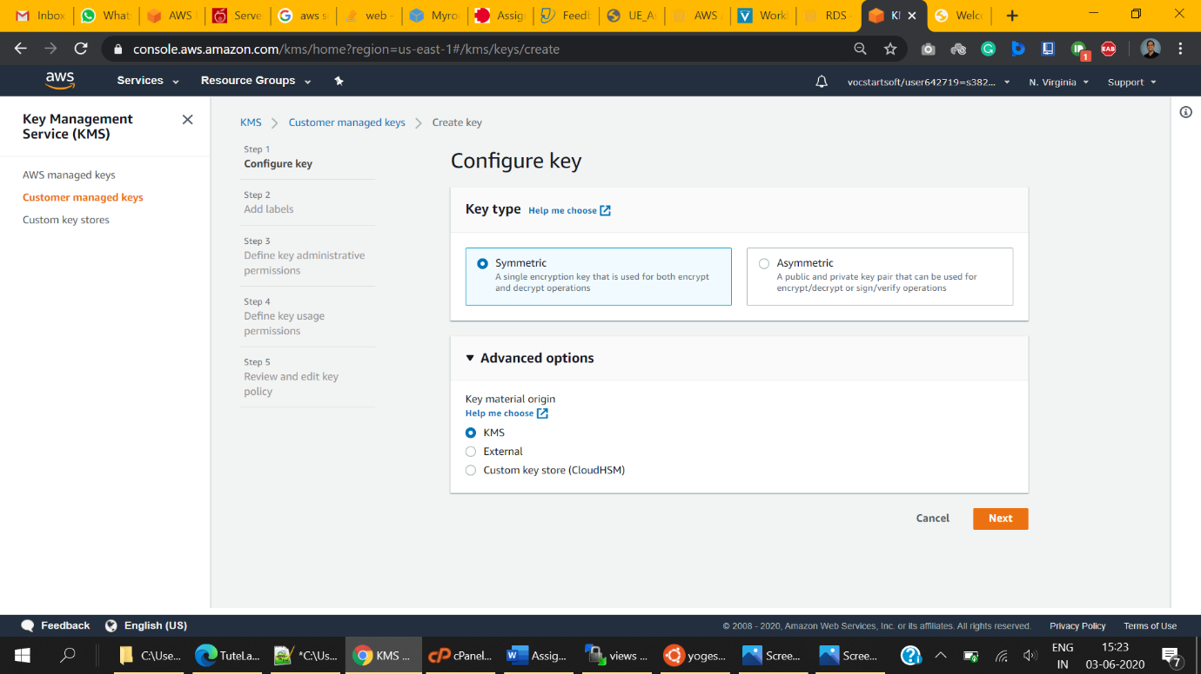
3. Add Labels
   1. Provide Descriptive Alias name for Key
   2. Provide Descriptive description for the key so that it can be understood by others.
   3. Click Next  
      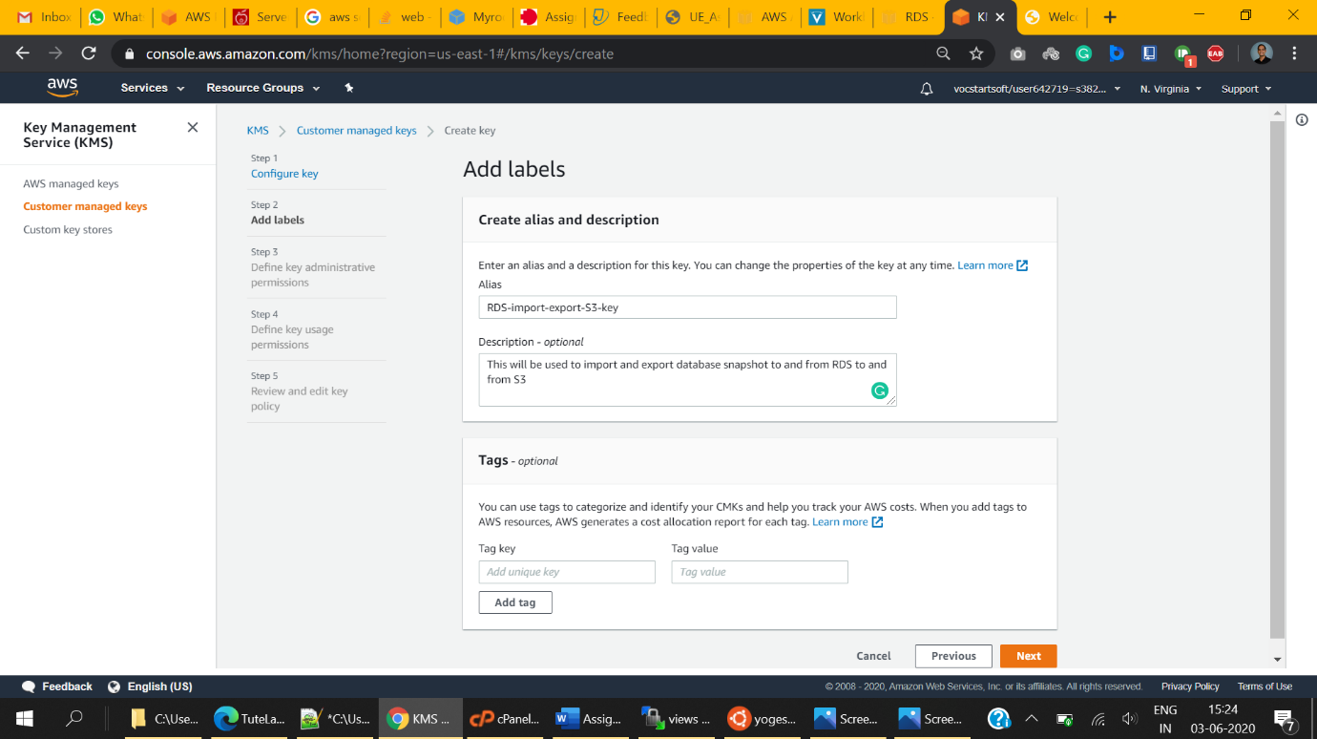
4. **Define Key Administrative Permissions**
   1. Select the roles that can manage this key. Enable deletion by administrators as per requirements.  
        
      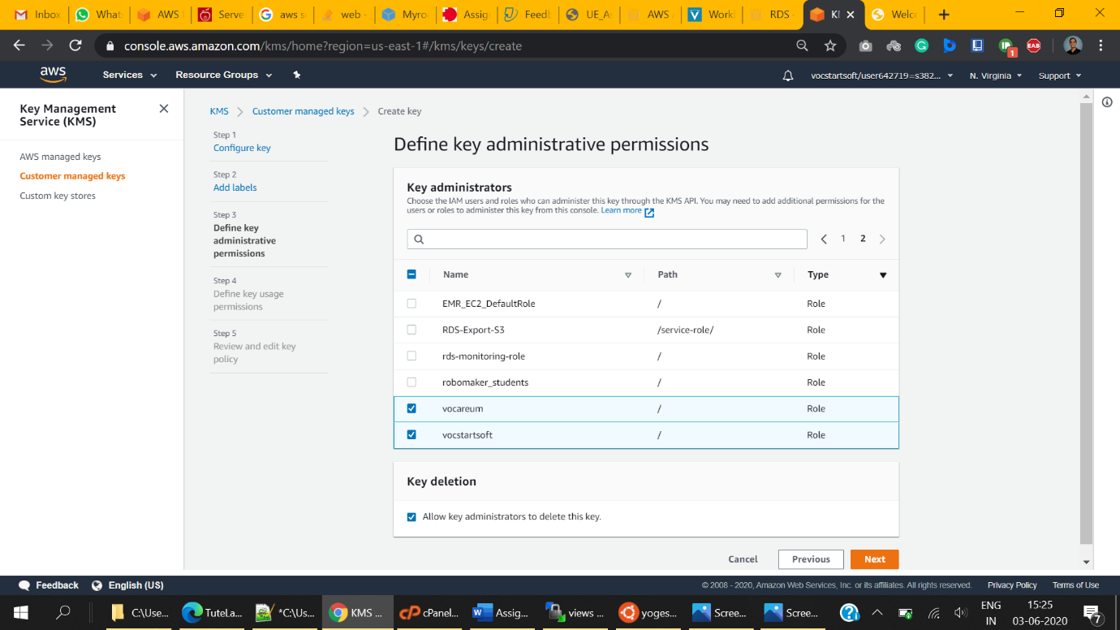
5. **Define Key Usage Permissions**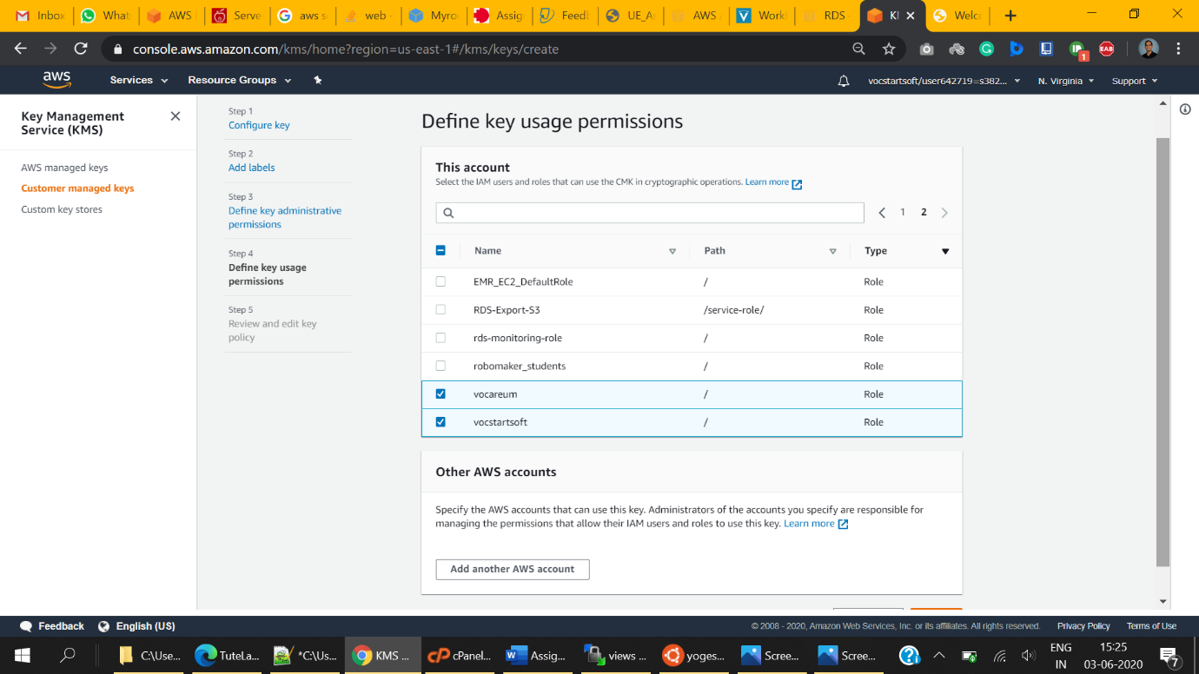
6. **Review Key Policy and Finish**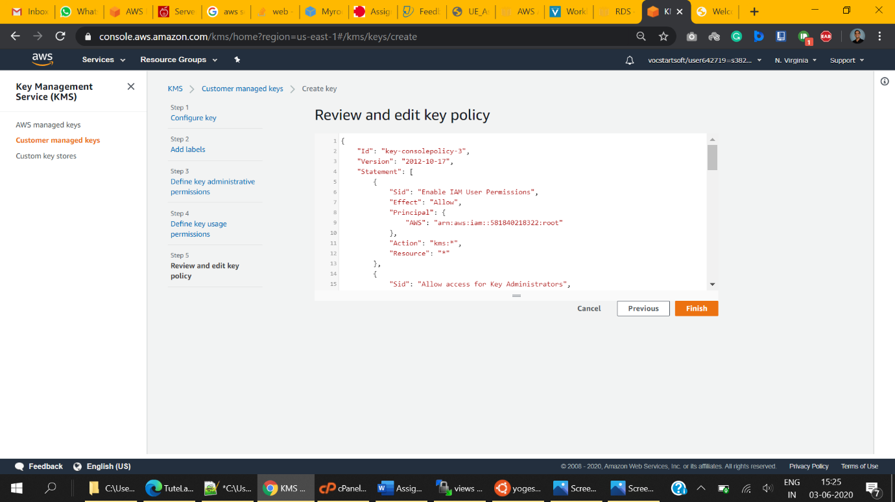

**Exporting RDS snapshot to S3 Bucket**

1. Under Snapshots -> Manual -> Click DB snapshot
2. Initiate Snapshot Process
   1. Provide the instance of which snapshot to be taken
   2. Provide snapshot name so that it can be identified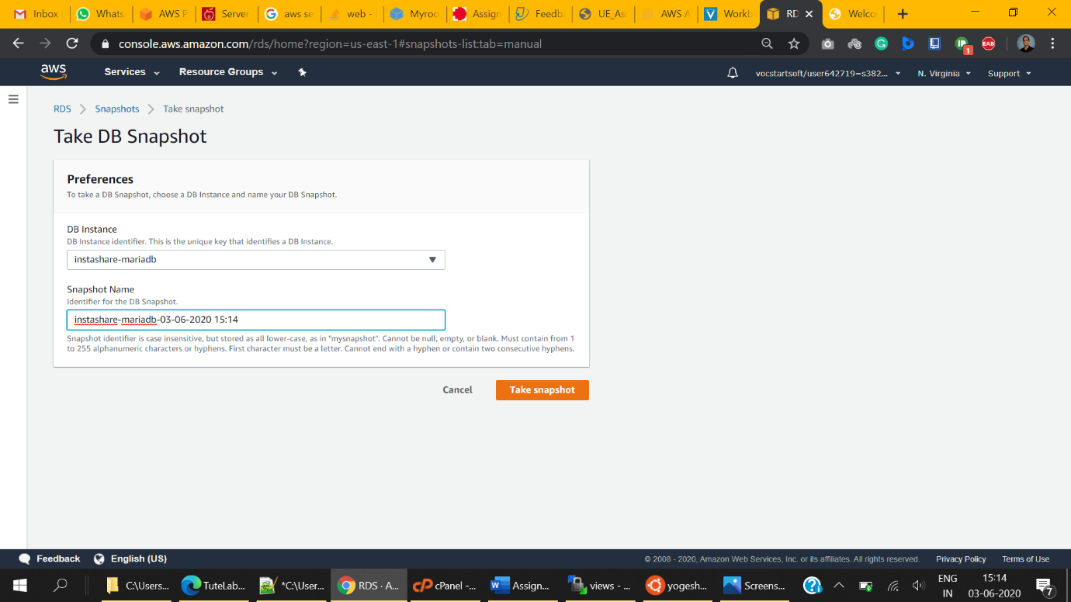
3. Snapshots -> Manual a new entry will appear for current snapshot.
   1. This process might take several minutes. Keep watching the progress variable of the process and wait until it changes to **Completed**
   2. Use scrollbar to see these variables
   3. Variables do not refresh on their own. Refresh the page to see the updated value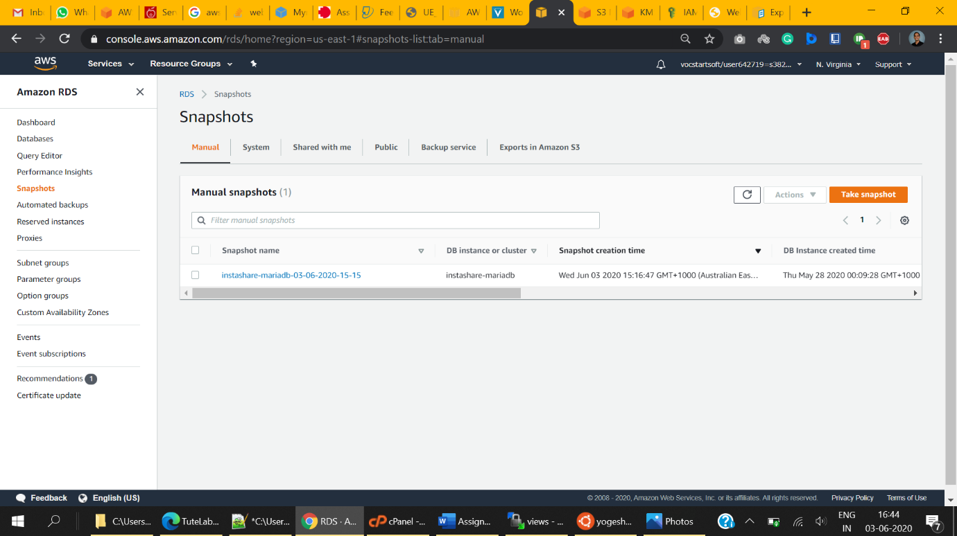
4. Select the snapshot using checkbox appearing before the name of the snapshot.
5. Select Export to S3 under Actions  
   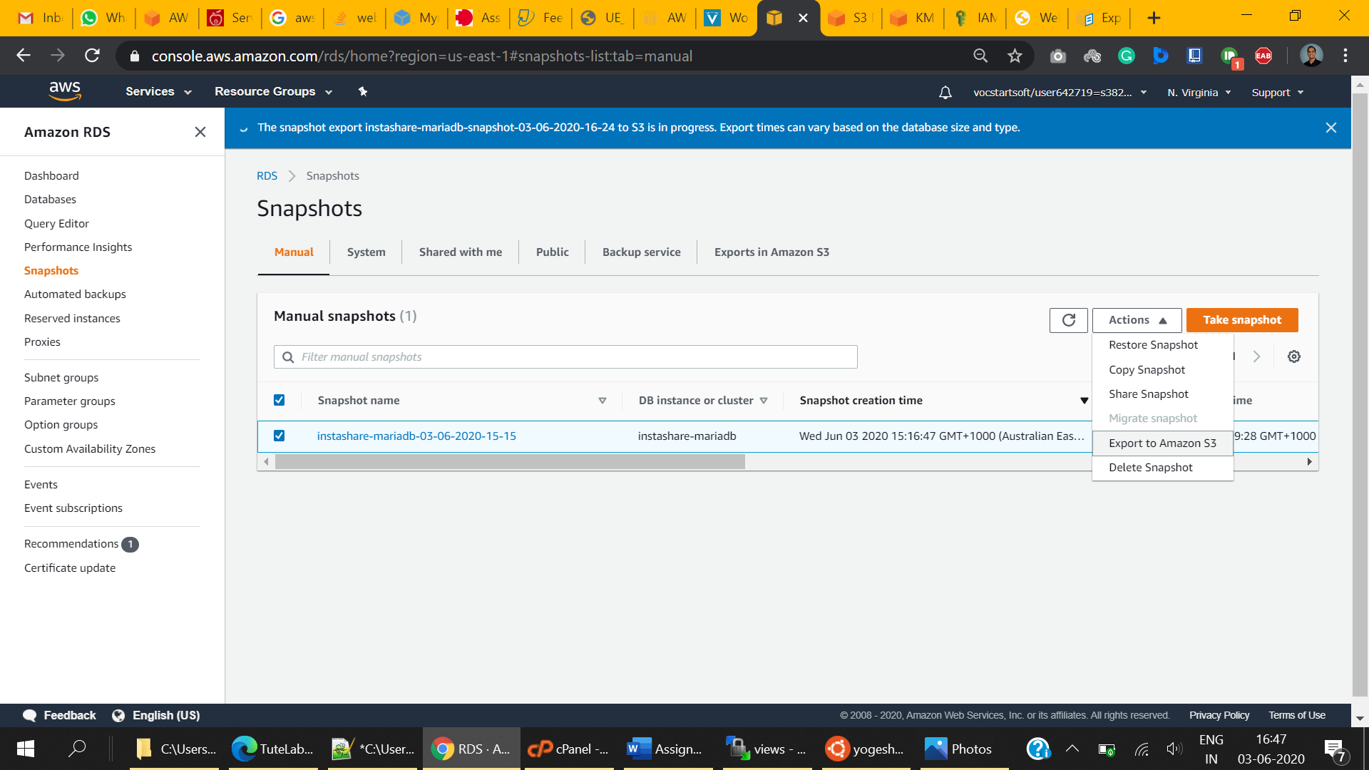
6. Export to Amazon S3
   1. Provide Export Identifier to identify the exports later   
        
      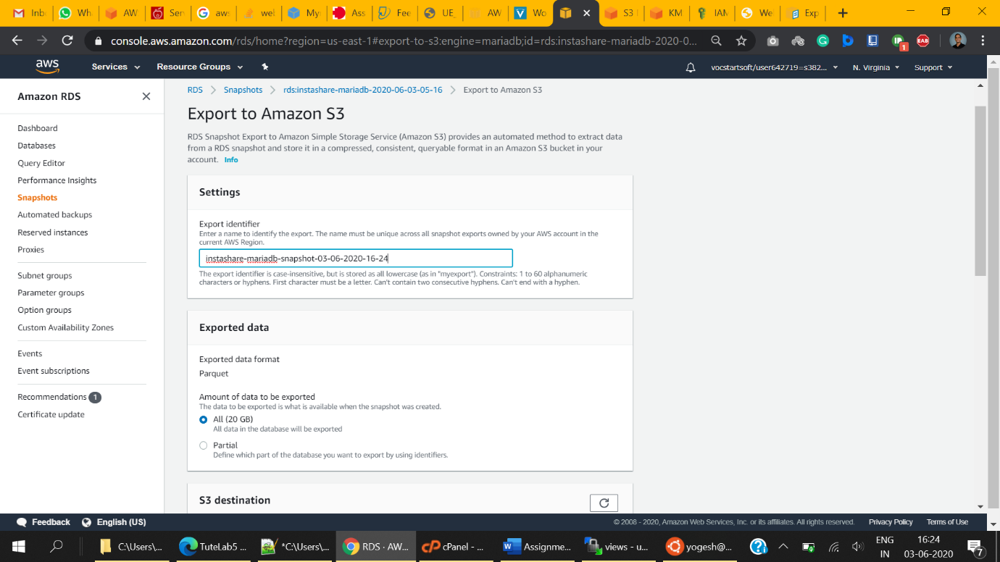
   2. Chose the bucket that we created for storing database backups.
   3. instashare-database-backup-bucket in this case.  
        
      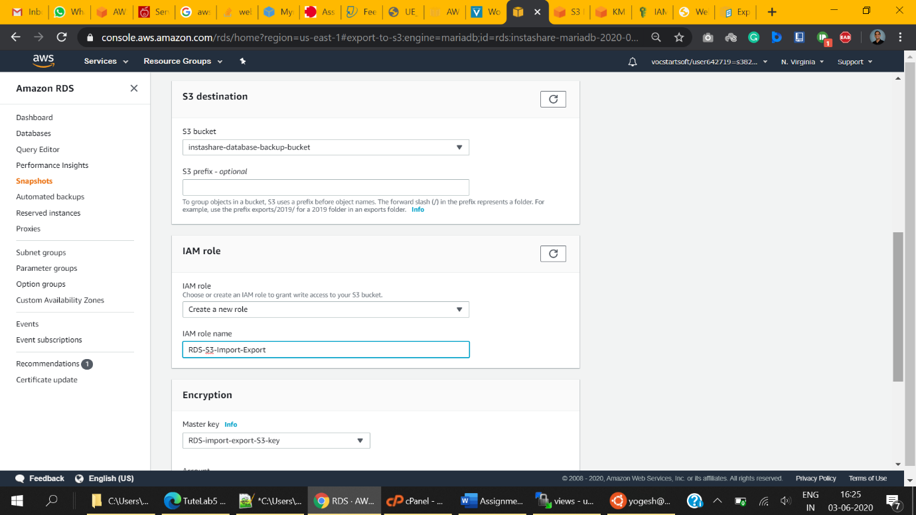
   4. If you have performed this activity earlier then you may choose to select an existing IAM service role for exporting the database.  
      I am creating a new role this time for demonstration purposes.  
        
      
   5. Select Create a new role
   6. Provide a descriptive IAM role name
   7. Select the master key we created in earlier steps. If it doesn’t appear then click the refresh button on that car.   
      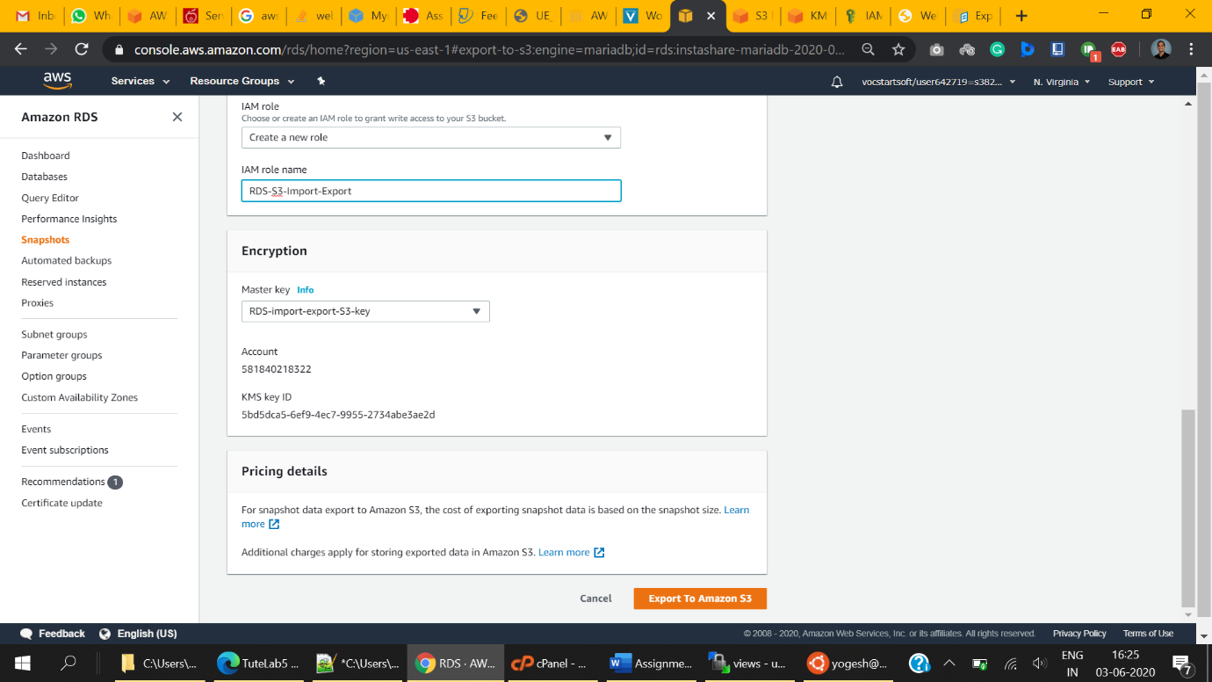
   8. Click Export to Amazon S3 to begin Exporting
   9. All exports will appear under RDS Console -> snapshots -> Export to S3
   10. The export process may take several times depending on current activity. Please wait until its status changes to **“Complete”**  
       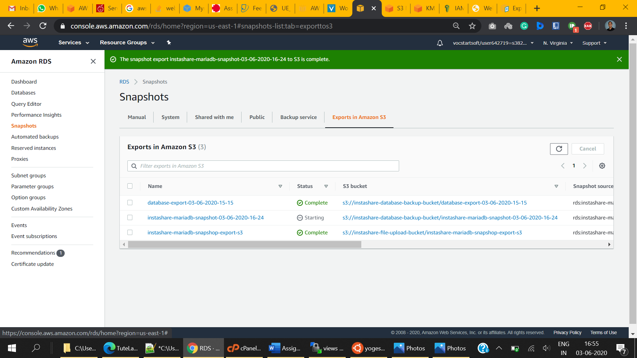

References :

### Pusher | Leader In Realtime Technologies Pusher | Leader In Realtime Technologies (2020). Available at: <https://pusher.com/>

### Justin Dorfman, X. Justin Dorfman, X. (2020) Bootswatch, Bootstrapcdn.com. Available at: https://www.bootstrapcdn.com/bootswatch/

### Templates, A. and Tim, C. Templates, A. and Tim, C. (2020) Now UI Dashboard by Creative Tim, Creative-tim.com. Available at: <https://www.creative-tim.com/product/now-ui-dashboard>

### Dashboard, P., Templates, A., Dashboard, P. and Tim, C. Dashboard, P. et al. (2020) Paper Dashboard by Creative Tim, Creative-tim.com. Available at: https://www.creative-tim.com/product/paper-dashboard

### darkwhispering/pusher-for-codeigniter - darkwhispering/pusher-for-codeigniter (2020). Available at: https://github.com/darkwhispering/pusher-for-codeigniter

### CodeIgniter Web Framework CodeIgniter Web Framework (2020). Available at: <https://codeigniter.com/>

### Bootstrap Notify v3.1.3Bootstrap Notify v3.1.3 (2020). Available at: <http://bootstrap-notify.remabledesigns.com/>

### Dropzone.jsDropzone.js (2020). Available at: https://www.dropzonejs.com/

### AWS Pricing Calculator AWS Pricing Calculator (2020). Available at: https://calculator.aws/

### Amazon Web Services (AWS) - Cloud Computing Services Amazon Web Services (AWS) - Cloud Computing Services (2020). Available at: https://aws.amazon.com/